Market Functionality Index — Benin
Assessment period: 2026-06-05 to 2026-06-17
Methodology: Scores and tables follow databridge-current. Summaries are unweighted descriptions of assessed markets and are not population-representative country estimates.

Executive summary
Between June 5 and June 17, 2026, a Market Functionality Index assessment was conducted across 53 markets in Benin. The overall unweighted mean MFI score across these assessed markets was 5.56 out of 10, with individual market scores ranging from a low of 3.81 in Sékou to a high of 8.04 in Parakou. The assessment identifies Service, Infrastructure, and Food Quality as the primary priority dimensions for monitoring and further consultation. In contrast, the assessed markets demonstrated robust supply environments, with Availability (9.81), Access & Protection (9.36), and Competition (9.28) recording the highest dimension scores. Across the surveyed locations, an unweighted mean of market-level rates of 100% reported no disaster-related access limitations, and market power was widely distributed, with near-total absence of single-trader control. The Service dimension is the weakest performing area, scoring 3.55, aligning with highly informal trade environments. An unweighted mean of market-level rates indicated that automatic itemized receipts were present at just 0.1%, and visible price tags at only 6.2%. Furthermore, remote purchase capabilities were recorded at an unweighted mean of market-level rates of 6.9%, illustrating that transactions heavily rely on physical presence and informal negotiation. Infrastructure (5.77) also poses significant constraints. An unweighted mean of market-level rates of only 11.3% recorded the presence of walkways and emergency exits. Additionally, the unweighted mean of market-level rates for uninterrupted electricity was 56.6%, and closed sewage systems were present at a rate of 26.4%. These physical deficits represent limitations to the operational capacity of the assessed markets. Food Quality (6.14) exhibits critical gaps in preservation and stock rotation. Alarmingly, the unweighted mean of market-level rates for products not being expired was only 5.7%. Furthermore, continuous refrigeration was reported at an unweighted mean of market-level rates of 37.7%, and visible spoilage was absent at a rate of only 47.2%, indicating product degradation is a recurring issue within the assessed locations. Among the lowest-performing markets, Sékou (3.81) and Ouègbo (3.83) in the Atlantique region exhibited severe structural and service limitations, recording scores of 0.0 or near 0.0 for Checkout and Shopping Services. Dangbo (4.43) and Banikoara (4.45) similarly demonstrated profound constraints in infrastructure condition and food preservation capabilities. The findings presented are unweighted descriptions of the specific included markets and do not represent population-representative estimates for Benin. Additionally, the processed data do not provide reliable item-specific trader denominators. Based on the evidence, recommendations include conducting feasibility assessments for infrastructure upgrades, particularly regarding water and waste management. Further verification is requested to monitor food expiration tracking practices and to consult local traders on the barriers limiting the modernization of checkout services.

Country context
Benin is a coastal West African country characterized by diverse ecological zones, ranging from the humid Gulf of Guinea in the south to the drier Sahelian zone in the north [S3]. Livelihoods predominantly rely on smallholder rainfed agriculture, informal trade, livestock rearing, and fishing [S3]. While rural households primarily consume their own crop production, such as maize, cassava, yams, and sorghum, urban populations depend almost entirely on market purchases for food [S3]. Recent agricultural conditions have been relatively favorable, with the 2025 aggregate cereal production officially estimated at roughly 20 percent above the previous five-year average, a pattern aligning with government input subsidies [S4]. Consequently, retail prices for locally produced maize, rice, and sorghum decreased year-on-year by April 2026 [S4]. However, security conditions present a major contextual challenge in the northern border areas. Since 2019, the expansion of violent extremist activity from neighboring Burkina Faso and Niger coincides with the affected departments of Alibori and Atacora [S3, S4]. This insecurity corresponds to disrupted local livelihoods, restricted mobility, and internal displacement, alongside strained host community resources [S3, S4]. Furthermore, structural vulnerabilities and climatic hazards, including recurrent flooding in southern riverine areas and erratic rainfall in the north, persistently threaten agricultural activities and infrastructure [S3]. The MFI evidence focuses exclusively on the specifically assessed market environments and cannot be used to infer broader household purchasing power or regional economic outcomes.

Dimension scores across assessed markets
Dimension | Mean /10 | Markets
Assortment | 7.75 | 53
Availability | 9.81 | 53
Price | 8.00 | 53
Resilience | 8.61 | 53
Competition | 9.28 | 53
Infrastructure | 5.77 | 53
Service | 3.55 | 53
Food Quality | 6.14 | 53
Access & Protection | 9.36 | 53
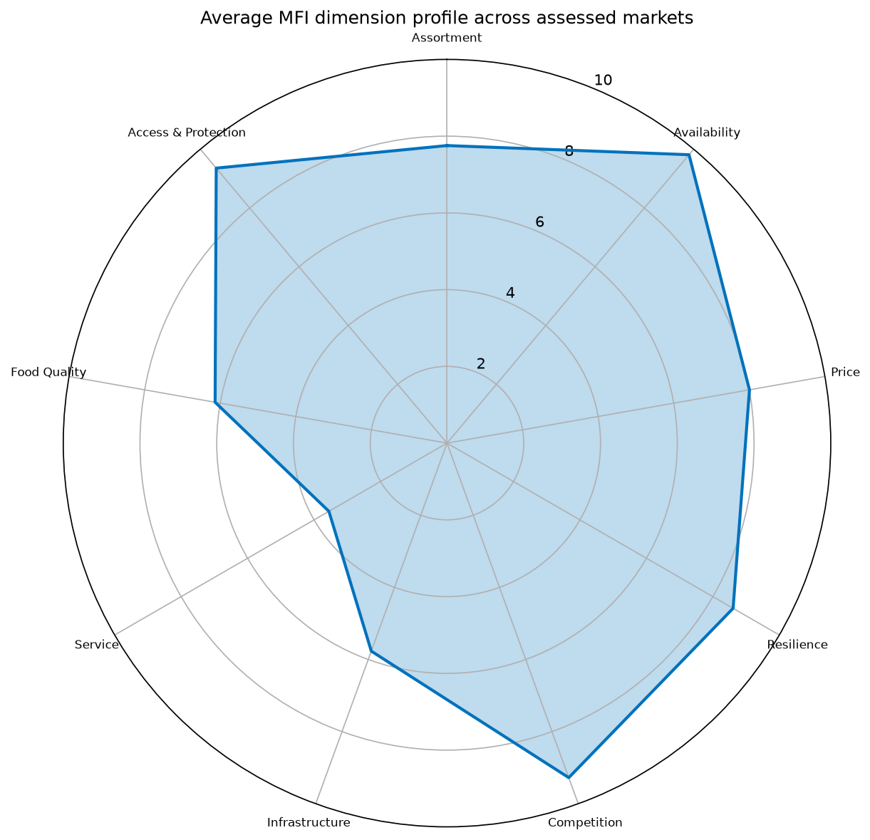
mfi radar
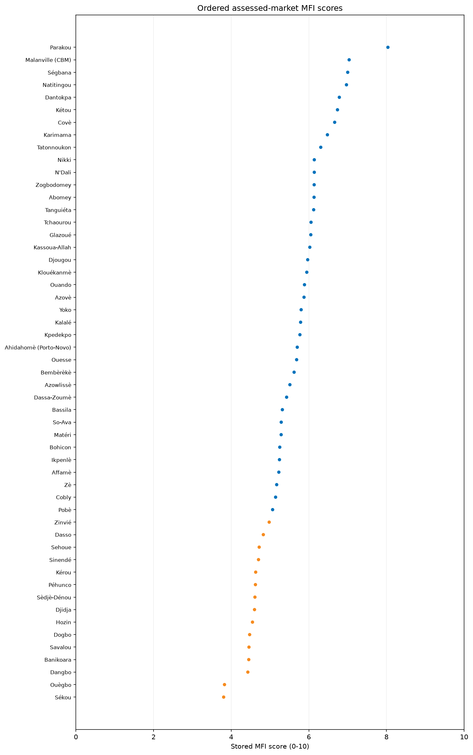
market score ranking
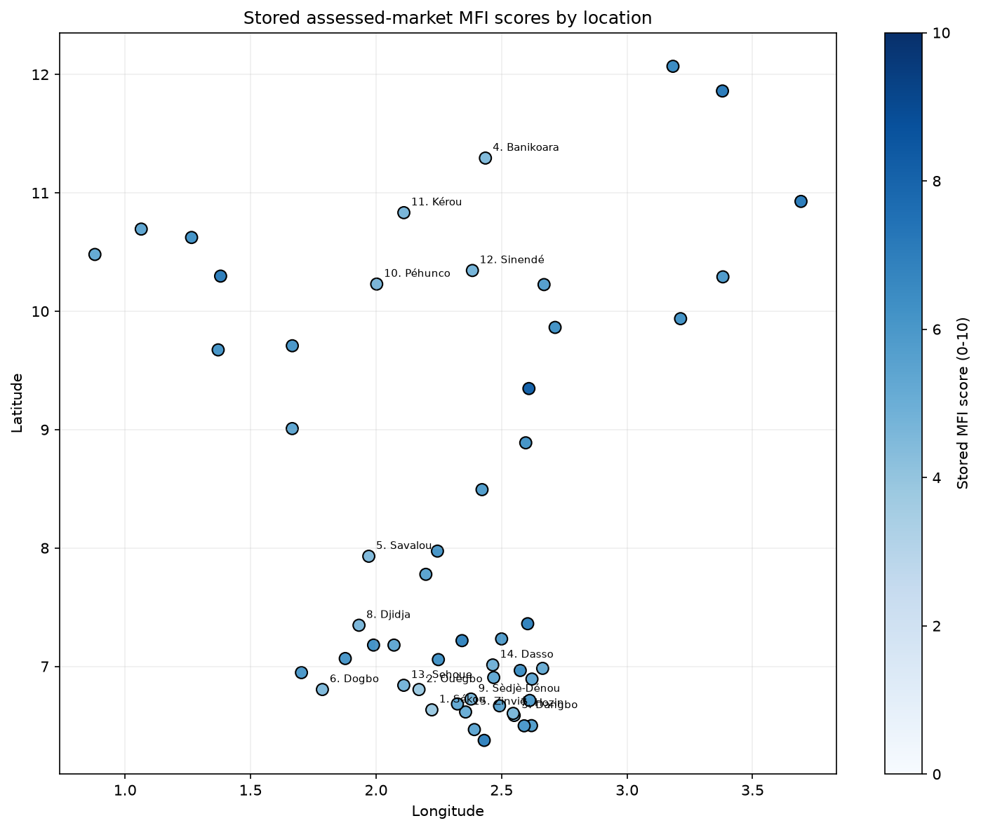
geographic map
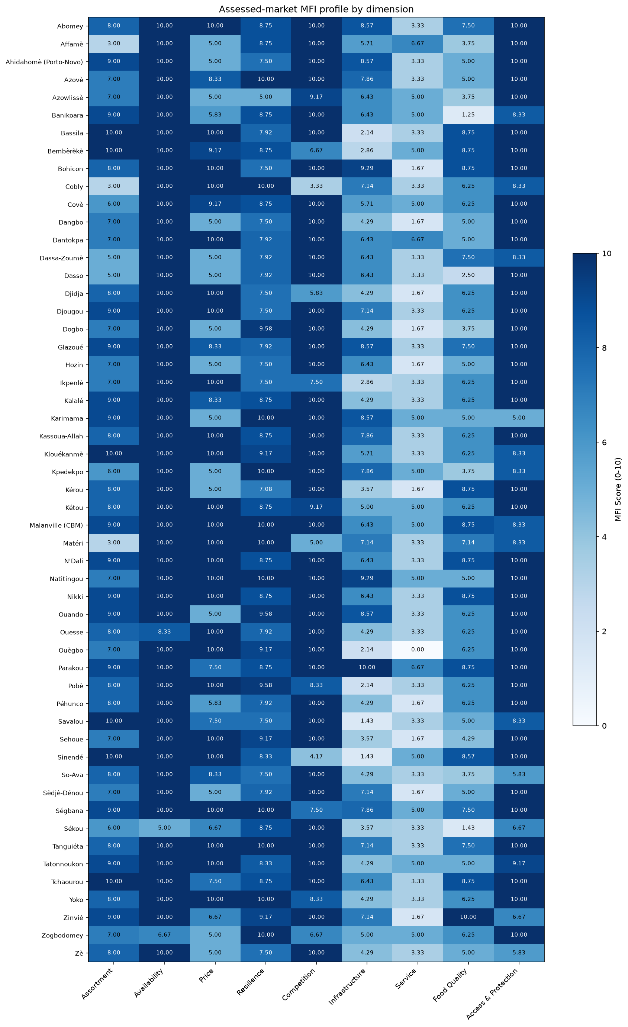
overview table

MFI dimensions

Assortment
Assortment in the 53 assessed markets in Benin indicates moderate variety and depth, recording an unweighted mean score of 7.75/10. A total of 33 of 53 assessed markets scored at or below the median of 8.00/10, while 47 markets scored below 10/10 and three scored below 5/10. Regionally, the unweighted mean Assortment score ranged from a maximum of 9.43/10 in Borgou to a minimum of 6.17/10 in Atakora. The overall dimension score is comprised of the Assortment breadth and Assortment depth subsections, which achieved normalized scores of 8.14/10 and 6.86/10, respectively. These scores reflect the broad availability of staple product groups, though the range of specific food items and overall stock keeping unit (SKU) counts vary across the assessed markets.
In terms of Assortment breadth, the unweighted mean of market-level rates showed universal presence for cereal food, other food, and household items (each at 10.00/10, or 100%). Other non-food item categories saw robust, though slightly lower, presence, including WASH (96.2%), communication items (90.6%), education materials (84.9%), and shelter items (75.5%). Health items were comparatively less prevalent, observed at an unweighted mean of market-level rates of 22.6%. The cereal food assortment was dominated by maize (76.1%), rice (56.6%), and sorghum (52.2%), which are central to local diets and livelihoods [S3]. Less prevalent cereals included millet (32.7%), flour (29.0%), wheat (17.5%), and pasta (13.6%), while items such as bread, barley, and cassava had extremely limited presence. Within the other food category, herbs, condiments, and spices achieved the highest presence (42.7%), followed by oils and fats (36.9%) and milk and dairy products (29.6%). Fresh and perishable items like legumes, nuts, and seeds (24.8%), fruits and vegetables (20.9%), roots and tubers (17.9%), and meat, fish, and eggs (13.5%) were found less frequently, underscoring constraints in the continuous availability of diverse dietary options.
Assortment depth, which measures the volume of distinct SKUs, demonstrated constraints in overall market capacity. The descriptive distribution of SKU depth indicates that an unweighted mean of market-level rates of 41.5% fell into the 51-200 SKU category. Meanwhile, 24.5% of markets were characterized by 1-50 SKUs, and 22.6% fell into the 201-1,000 SKU range. Large-scale assortment depth was relatively rare, with more than 1,000 SKUs recorded at an unweighted mean of market-level rates of just 11.3%.
The assessed markets in Atakora and Zou reported the lowest regional scores. Contextual factors indicate structural vulnerabilities and regional security dynamics in northern border areas [S3]. Limitations to this assessment include the fact that these unweighted descriptions represent only the included assessed markets and are not population-representative estimates for Benin as a whole. Additionally, item-level trader denominators were unavailable, meaning item eligibility relies on market-level coverage rather than exact trader counts. Recommendations include continued monitoring of market assortment, particularly for perishable foods and health items, and further feasibility assessments to understand the constraints limiting deeper SKU inventories in northern departments.
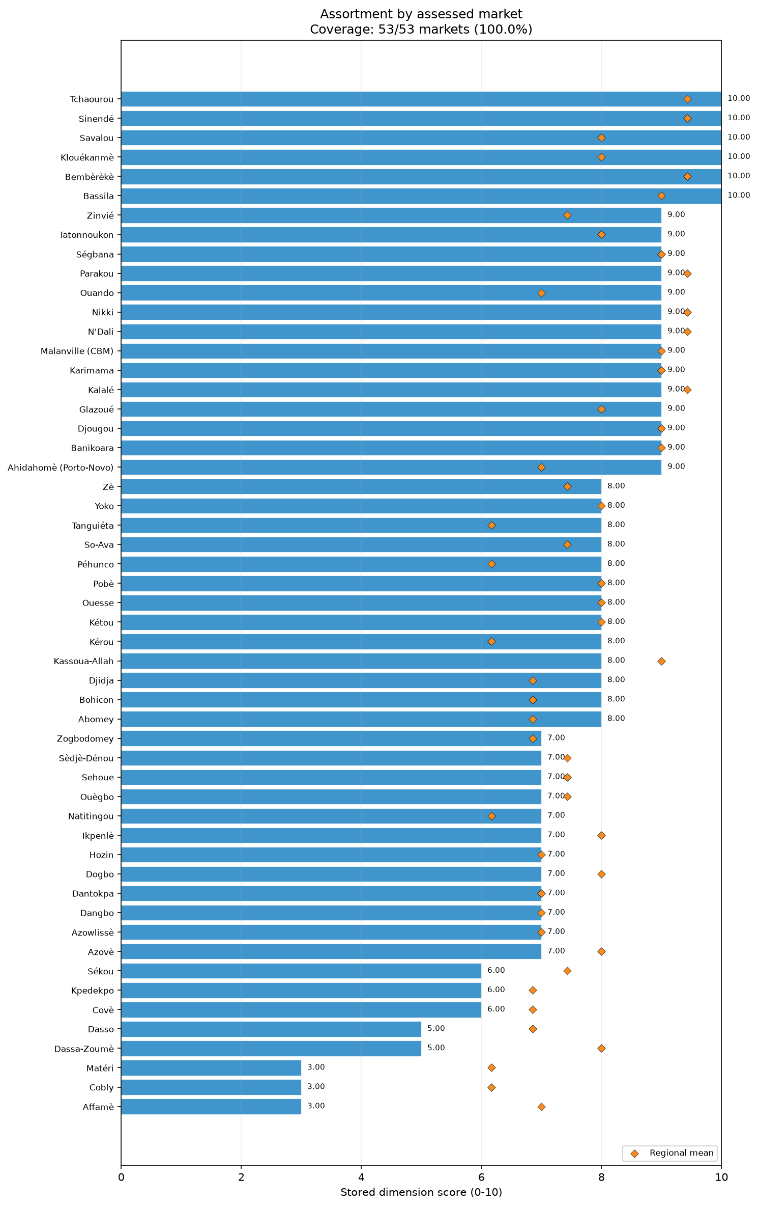
dim assortment bars

Availability
The Availability dimension in Benin demonstrates very strong market supply conditions, recording an unweighted mean score of 9.81/10. All 53 assessed markets scored at or below the median of 10.00/10, with only three markets scoring below 10/10 and a single market falling below 6/10. Across the country, several regions including Alibori, Atakora, Borgou, Couffo, Donga, Littoral, Oueme, and Plateau reached the maximum regional mean of 10.00/10. The lowest unweighted regional mean was observed in Atlantique at 9.29/10. The dimension is divided into two official subsections: Absence of scarcity and Absence of imminent runout, which scored 9.84/10 and 9.78/10, respectively. These figures highlight robust supply chains capable of meeting current market demands, with very few widespread shortages observed during the collection period.
The Absence of scarcity subsection recorded high performance across all major product groups. The unweighted mean of market-level rates for not being scarce was 95.1% for non-food items, 93.7% for cereal food, and 93.1% for other food items. Scarcity was largely localized and item-specific rather than systemic. For instance, among non-food items, health products faced a scarcity problem rate at an unweighted mean of market-level rates of 33.3%, though this figure is drawn from limited market coverage. Communication and education items recorded scarcity rates of 11.8% and 7.1%, respectively, while household items and WASH products had negligible scarcity rates below 3%. Within the cereal group, wheat recorded the highest scarcity rate at 10.9%, followed by millet at 3.4%. Primary staples such as maize and rice had minimal scarcity rates (1.4% and 1.5%, respectively). For other food items, other non-cereal food was scarce at a rate of 8.9%, followed by milk and dairy products (3.1%) and legumes, nuts, and seeds (2.8%).
Similarly, the Absence of imminent runout subsection confirms stable immediate supply horizons. The unweighted mean of market-level rates indicating no runout was 95.3% for non-food items, 92.1% for cereal food, and 89.5% for other foods. The item-level runout problem rates mirrored the scarcity patterns. Health items again showed a 33.3% runout problem rate under limited coverage. Other non-cereal food items registered a runout rate of 14.3%, while wheat stood at 8.7%. Runout rates for herbs, condiments, and spices, as well as fruits and vegetables, were recorded at 6.4% and 6.2%, respectively. Sorghum runout issues were reported at 6.0%, and staple cereals like maize and rice recorded runout problem rates of just over 4%.
Despite the expansion of security issues and displacement in northern areas like Alibori and Atakora [S3, S4], these departments achieved maximum Availability scores. This contrasts with the broader contextual challenges in these regions. However, recurrent climatic hazards such as flooding and erratic rainfall remain contextual risks [S3]. Limitations of this analysis include the unweighted nature of the scores and insufficient market coverage for specific items such as barley, bread, and health products, which constrained deeper item-level contrast. Recommendations focus on ongoing monitoring of health item availability and verification of supply chain resilience for wheat and fresh food items in markets exhibiting localized runout concerns.
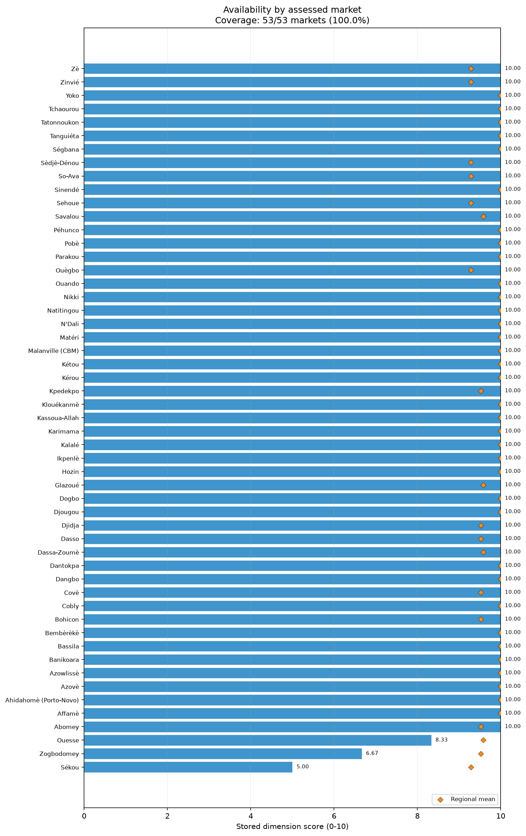
dim availability bars

Price
The Price dimension for the assessed markets in Benin reflects significant volatility and upward pressure, resulting in an unweighted mean score of 8.00/10. The median score was 9.17/10, with 28 of the 53 assessed markets scoring at or below the median. Twenty-six markets scored below 9/10, and 17 scored below 6/10, indicating notable variability across locations. Regionally, Donga, Littoral, and Plateau recorded the maximum unweighted mean Price score of 10.00/10, while Oueme had the lowest score at 5.00/10. The dimension comprises two subsections: Absence of recent large price increases, which scored highly at 9.75/10, and Price stability and predictability, which performed poorly at 6.26/10. The data do not establish whether these prices align with local purchasing power or affordability, merely the directional behavior of the costs in the assessed markets.
The Absence of recent large price increases subsection reveals that the majority of product groups avoided sudden, severe spikes. The unweighted mean of market-level rates for prices not having increased was 93.4% for cereal food, 92.5% for non-food items, and 90.2% for other food. The highest price increase rate within non-food items was for health items at 33.3% (subject to low coverage), followed by communication and shelter items at 5.9% each. Within other foods, fruits and vegetables experienced a price increase rate of 12.5%, roots and tubers saw 7.4%, and herbs, condiments, and spices stood at 6.4%. For cereals, wheat had the highest price increase rate at 8.7%. Maize and rice had very low increase rates of 2.8% and 3.7%, respectively. This broad absence of severe, sudden price jumps aligns with contextual reports indicating that retail prices of locally produced rice, maize, and sorghum either stabilized or decreased year-on-year by April 2026, supported by average to above-average harvests and government subsidies [S4].
Conversely, the Price stability and predictability subsection highlights widespread fluctuation. The unweighted mean of market-level rates for price stability was 60.9% for cereal food, 59.2% for non-food items, and 56.6% for other food. Instability was pervasive across essential commodities. Herbs, condiments, and spices recorded a high instability rate of 42.0%, followed closely by household non-food items at 40.1%. Multiple staple and fresh foods demonstrated substantial instability: flour (37.5%), fruits and vegetables (37.5%), roots and tubers (37.0%), maize (35.0%), legumes, nuts, and seeds (34.7%), and dairy products (32.6%). Other heavily traded cereals, such as millet (31.6%), wheat (31.2%), sorghum (30.3%), pasta (30.2%), and rice (28.2%), also recorded significant unpredictability.
Contextual factors, including rising agricultural input costs, structural vulnerabilities, and cross-border trade dynamics, are consistent with the observed pricing environment [S3]. While recent harvests coincided with fewer extreme price spikes, the persistent instability underscores the ongoing fluctuations faced by market actors. Limitations include insufficient market coverage for minor items like bread and barley, and the fact that these figures represent unweighted descriptions of assessed markets, not population-wide estimates. Recommendations include further monitoring of price instability for crucial staple cereals and fresh foods, as well as feasibility assessments concerning the pricing dynamics in the Oueme region.
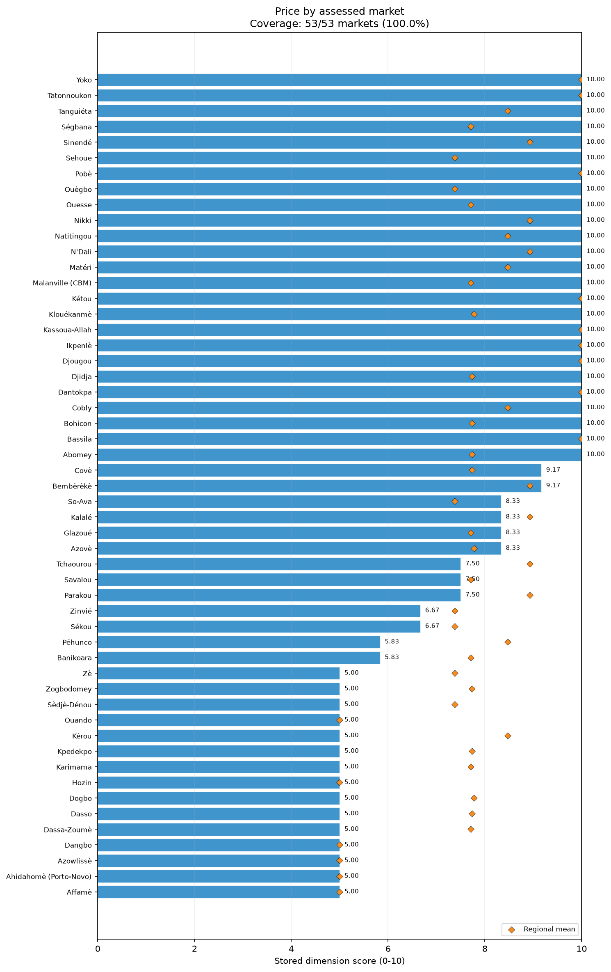
dim price bars

Resilience
The Resilience dimension in Benin’s assessed markets is relatively strong, with an unweighted mean score of 8.61/10 and a median of 8.75/10. Among the 53 assessed markets, 35 scored at or below the median. Most markets clustered in the higher ranges, though 20 markets scored below 8/10 and one fell below 6/10. Alibori achieved the highest unweighted regional mean at 9.69/10, while Oueme recorded the lowest at 7.64/10. The dimension is driven by two subsections: Supply-chain responsiveness, which performed exceptionally well at 9.91/10, and Low vulnerability to disruption, which scored 8.18/10. These results depict a market system capable of rapid restocking and sustained inventory, though vulnerabilities exist regarding the geographic concentration of suppliers.
Supply-chain responsiveness is a core strength of the assessed markets. An unweighted mean of market-level rates of 95.8% indicated that replenishment was expected within one week. Similarly, 90.5% of market rates showed that current stock was expected to last at least one week. These figures highlight agile supply networks that allow traders to maintain a continuous flow of goods without relying on vast long-term storage, which is particularly relevant for perishable foods and daily necessities.
The Low vulnerability to disruption subsection presents a more complex picture. A positive feature of the market networks is the high degree of supplier diversity and the absence of single-supplier dependence. The unweighted mean of market-level rates for supplier diversity was 92.6% for other food, 92.2% for cereal food, and 91.1% for non-food items. Furthermore, the absence of single-supplier dependence was nearly universal, recorded at 94.8% for non-food items, 92.9% for other food, and 88.8% for cereal food. This limits the potential for total supply failure if individual distributors encounter operational difficulties.
However, the geographic dispersion of these suppliers represents a notable vulnerability. The unweighted mean of market-level rates for geographic supplier dispersion was only 36.2% for cereal food, 48.4% for other food, and 63.0% for non-food items. This indicates that while traders use multiple suppliers, those suppliers are largely concentrated in the same geographic areas. Such spatial concentration corresponds to risks related to localized shocks. Contextual reports note recurrent flooding in southern regions and erratic rainfall in the north, along with extremist activity in the northern borderlands of Alibori and Atakora [S3, S4]. Because suppliers are not widely dispersed geographically, a localized climatic or security event frequently coincides with impacts on multiple supply nodes simultaneously.
Limitations of this assessment include the lack of population-representative data, as findings rely on unweighted descriptions of the 53 specific markets assessed rather than national figures. Additionally, trader-level denominators were not uniformly available. Recommendations focus on further consultation and verification regarding the geographic concentration of cereal and food suppliers, and targeted monitoring of supply chain continuity in areas prone to seasonal flooding or borderland insecurity.
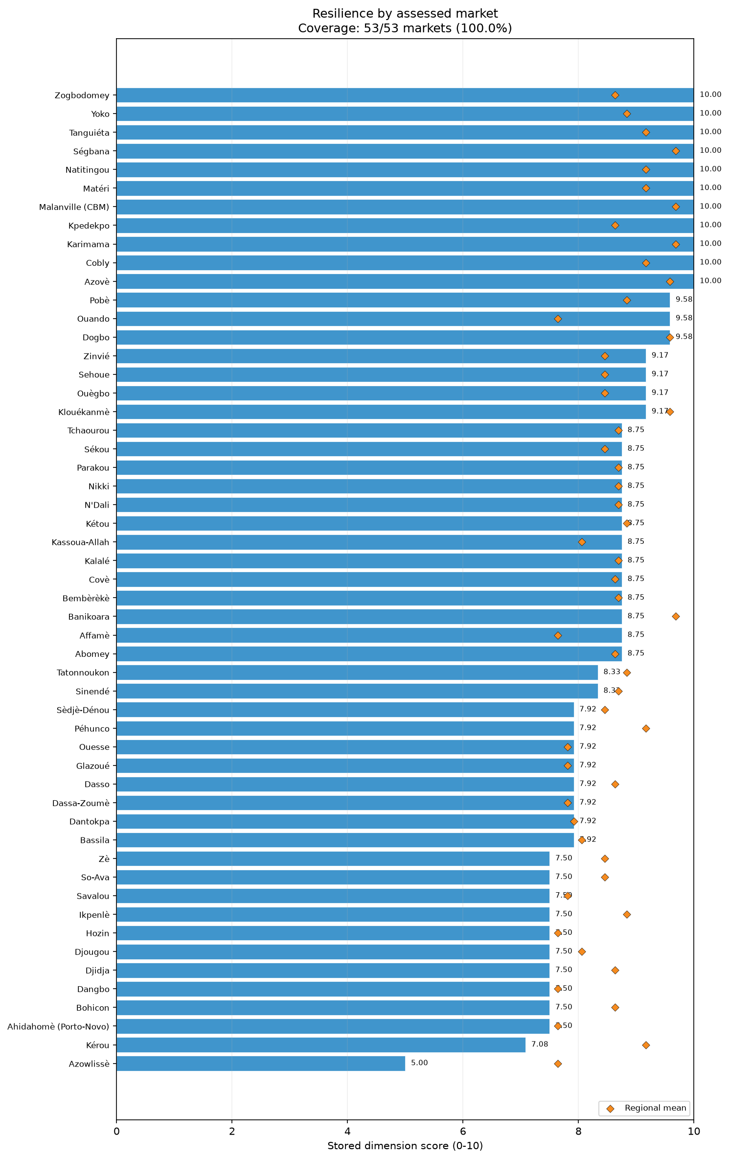
dim resilience bars

Competition
The Competition dimension in the assessed markets of Benin is highly favorable, achieving an unweighted mean score of 9.28/10. The median score was a perfect 10.00/10, with all 53 markets scoring at or below this threshold. Twelve markets scored below 10/10, and only four scored below 6/10, indicating that while a few markets exhibit some constraints, the overwhelming majority enjoy robust trader participation. Regionally, Atlantique, Collines, Couffo, Donga, Littoral, and Oueme all registered the maximum or near-maximum unweighted mean scores, with Atlantique reaching 10.00/10. Atakora had the lowest regional mean at 8.06/10, which still represents a solid baseline of competition. The dimension relies on two subsections: Absence of single-trader control (9.56/10) and Sufficient trader concentration (8.99/10). These metrics underscore a vibrant, open market environment characterized by multiple active participants and minimal monopolistic practices across the assessed areas.
The Sufficient trader competition subsection, which assesses whether markets have at least five traders per product group, demonstrated robust participation. The unweighted mean of market-level rates for having at least five traders was 94.2% for cereal food, 92.2% for non-food items, and 88.5% for other food categories. This level of concentration indicates that buyers have varied options, characterizing a healthy competitive landscape. The slightly lower concentration for other foods corresponds to the specialized nature of certain perishable or non-staple items compared to ubiquitous cereal commodities.
The Absence of single-trader control (monopoly) subsection performed even higher, confirming that market power is widely distributed. The unweighted mean of market-level rates indicating no single trader controls the market was absolute at 100% for cereal food. Non-food items followed closely at 98.0%, and other food items recorded 94.2%. The near-total absence of monopolies reflects a structure where multiple actors operate simultaneously within the assessed markets, avoiding the consolidation of supply by isolated actors.
The exceptionally high competition scores align with contextual descriptions of Benin's economy, where informal trade and smallholder agriculture are very common in rural and urban livelihoods, coinciding with decentralized commercial activity [S3]. While Atakora recorded the lowest regional competition score, its 8.06/10 remains relatively strong. The slight dip in Atakora coincides with the internal displacement and cross-border insecurity documented in the northern departments, representing a pattern of co-occurring regional stress and marginally lower trader counts [S4].
Limitations to these findings include the unweighted nature of the data, meaning these insights apply only to the included assessed markets and cannot be extrapolated as national estimates. In addition, item-level trader denominators were unavailable, relying instead on market-level coverage parameters. Recommendations include continued monitoring of market competitiveness in the northern departments of Atakora and Alibori, and further feasibility assessments to observe trader concentration levels amid expanding regional security challenges.
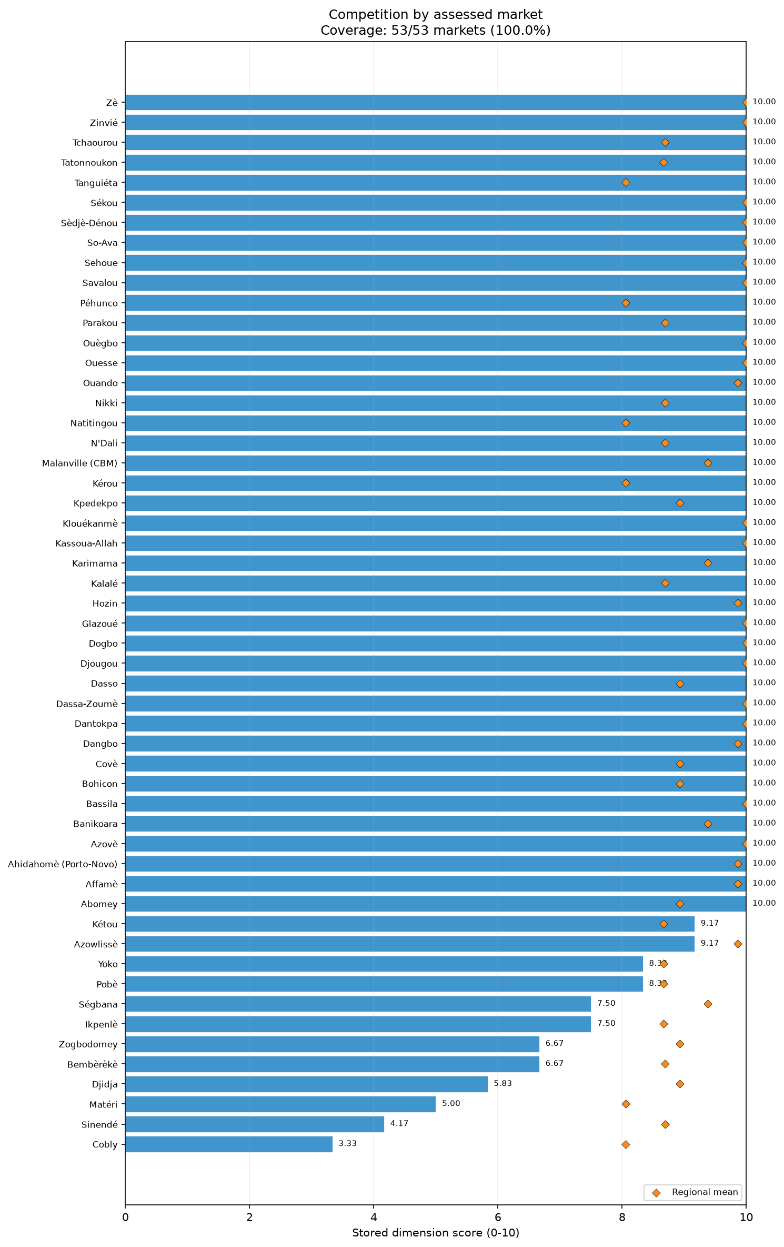
dim competition bars

Infrastructure
Infrastructure across the assessed markets in Benin exhibits significant deficits, reflected in an unweighted mean score of 5.77/10 and a median of 6.43/10. A total of 35 of the 53 assessed markets scored at or below the median, and a striking 20 markets scored below 5/10. Regionally, Alibori recorded the highest unweighted mean score at 7.32/10, while Plateau registered the lowest at 3.71/10. This dimension is structured around two subsections: Infrastructure features (5.64/10) and Infrastructure condition (5.94/10). The pervasive lack of essential physical amenities and the poor condition of existing facilities represent substantial constraints on optimal market functionality in the assessed locations.
The Infrastructure features subsection highlights critical gaps in market outfitting. An unweighted mean of market-level rates of only 11.3% recorded the presence of walkways and emergency exits, indicating severe limitations in safe physical navigation and crowd management. Closed sewage systems were also rare, present at a rate of 26.4%. Water availability was observed at an unweighted mean of market-level rates of 50.9%, presenting a systemic challenge for maintaining hygiene, particularly for fresh food vendors. Uninterrupted electricity was reported at 56.6%, and dedicated waste collection at 64.2%. More prevalent, yet not universal, features included toilets (73.6%), physical shelter (83.0%), and reliable communication networks (84.9%). The relatively high presence of communication networks supports basic trade logistics, but the absence of core structural amenities limits the sanitary and operational capacity of these markets.
The Infrastructure condition subsection further illustrates these constraints. Based on an unweighted mean of market-level rates, 56.6% of market infrastructure was in good condition. However, a descriptive rate of 66.0% characterized the infrastructure as being in medium condition, and 28.3% of the infrastructure was reported to be in poor condition. The presence of poorly maintained facilities co-occurs with the risks associated with absent features like proper sewage and waste collection.
Contextually, structural vulnerabilities and high rural poverty rates in Benin align with the systemic infrastructure deficits observed [S3]. Recurrent flooding in southern and riverine areas further coincides with challenges to the durability and maintenance of physical market structures [S3]. The extremely low score in the Plateau region warrants specific attention to local physical constraints in that area.
Limitations to these findings include their nature as unweighted descriptions of the specific assessed markets rather than a comprehensive national survey or population-representative estimates. The data reflect the conditions strictly during the collection period. Recommendations include undertaking detailed feasibility assessments to explore the improvement of water access, waste management, and drainage or sewage systems, particularly in markets prone to seasonal flooding. Further consultation with local authorities is requested to review the lack of walkways and the high proportion of infrastructure in poor condition across multiple departments.
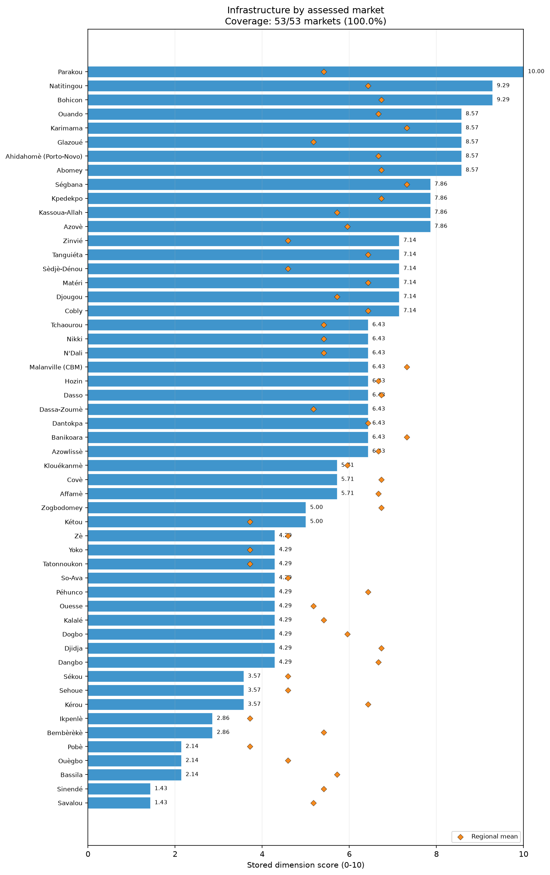
dim infrastructure bars
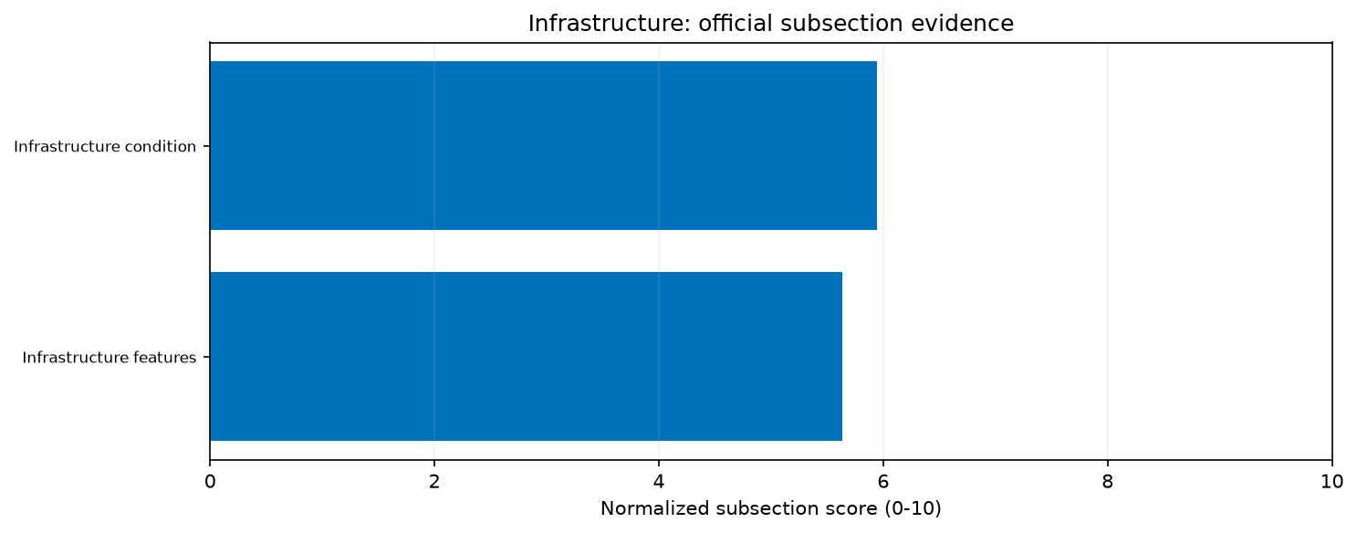
priority infrastructure subsections
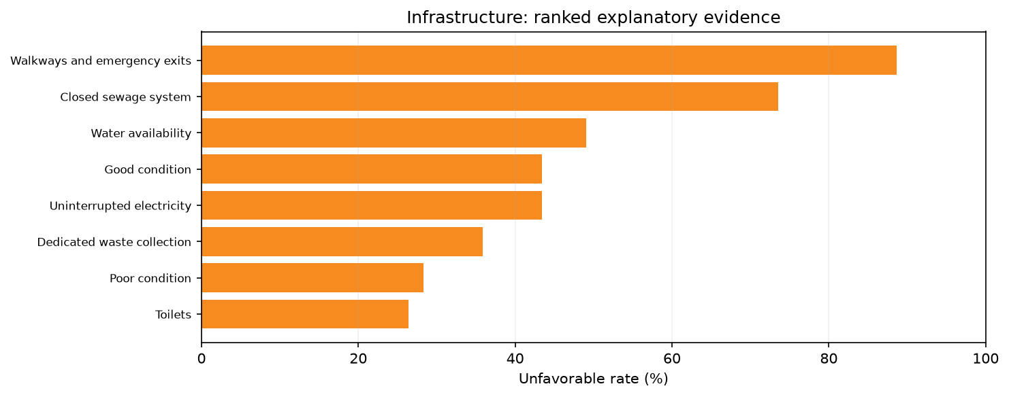
priority infrastructure drivers

Service
The Service dimension reveals profound underdevelopment across the 53 assessed markets in Benin, recording the lowest overall dimension score at an unweighted mean of 3.55/10. The median score was 3.33/10, with 37 markets scoring at or below this median. Every assessed market scored below 7/10, 37 markets scored below 5/10, and 11 markets scored below 2/10, underscoring the widespread nature of these service constraints. Regionally, Littoral achieved the highest unweighted mean score of 6.67/10, while Atlantique posted the minimum at 2.14/10. The dimension is composed of the Checkout service subsection (3.52/10) and the Shopping service subsection (3.58/10). These figures demonstrate that modern retail conveniences and customer-facing services are virtually non-existent, reflecting highly informal, traditional market environments across the country.
The Checkout service subsection underscores a lack of formalized transaction systems. The provision of an automatic itemized receipt was found at an unweighted mean of market-level rates of just 0.1%. Acceptance of multiple forms of payment was observed at a rate of 44.4%, indicating a heavy reliance on single payment methods, overwhelmingly cash. Checkout wait times below ten minutes were recorded at a rate of 56.5%, highlighting that nearly half of the transactions involve prolonged waiting. This pattern often co-occurs with informal negotiation and the lack of structured points of sale.
The Shopping service subsection similarly reflects traditional trade practices. Visible price tags were exceptionally rare, noted at an unweighted mean of market-level rates of 6.2%. This absence indicates that pricing is largely determined through informal haggling rather than fixed, transparent structures. Remote purchase capabilities were also extremely limited, recorded at 6.9%, restricting trade entirely to physical, in-person interactions. The only robust service feature was the display of products for easy selection, which was present at a rate of 95.6%, showing that while transactions are informal, physical goods are visibly arranged for consumers.
The prevalence of informal trade and smallholder commercial activity, as noted in the contextual background for Benin, perfectly aligns with these low service scores [S3]. Urban and rural households rely heavily on informal markets where personalized interaction supersedes formalized retail services. Limitations of this assessment include the fact that the scores are unweighted descriptions of the assessed locations and do not function as population-representative estimates. The findings are specific to the 53 markets evaluated. The low scores across all regions confirm that the lack of formal shopping and checkout services is a structural characteristic of the assessed retail environments rather than a localized deficit. Recommendations involve conducting further feasibility assessments regarding the integration of multiple forms of payment, which could support future retail modernization. Additional verification of the structural barriers and commercial norms preventing the adoption of visible pricing and itemized receipts is also requested to guide ongoing market monitoring.
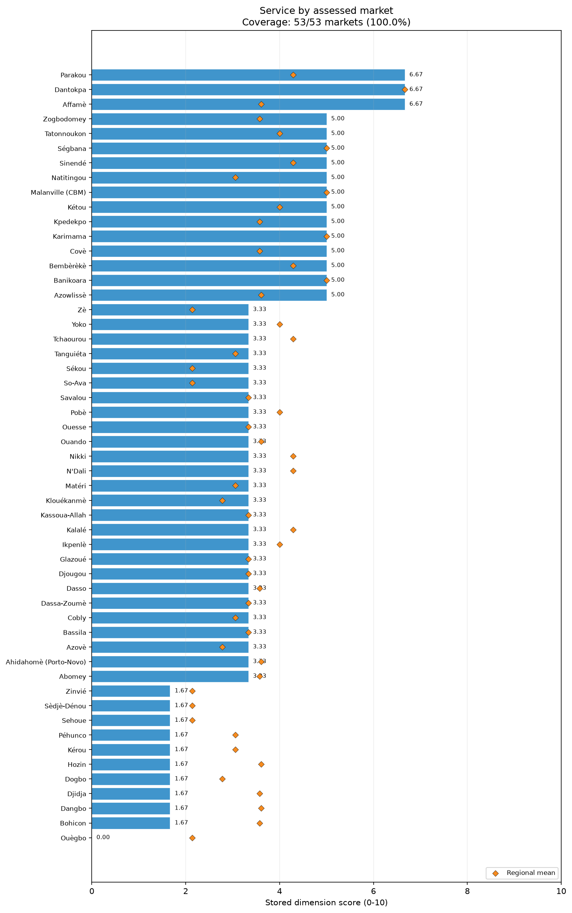
dim service bars
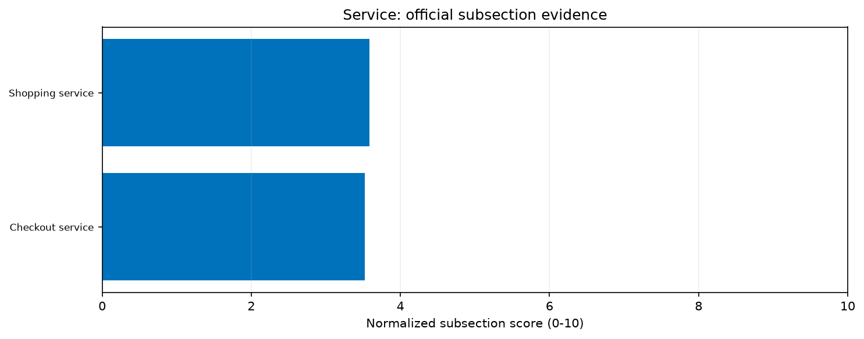
priority service subsections
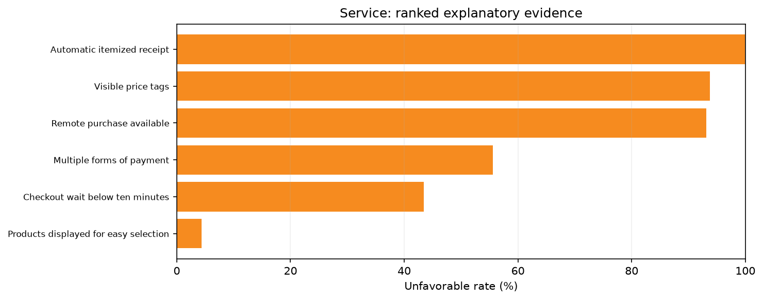
priority service drivers

Food Quality
Food Quality in the assessed markets of Benin presents significant areas of concern, yielding an unweighted mean score of 6.14/10. The median score stood at 6.25/10, with 36 of the 53 assessed markets scoring at or below this mark. Twenty markets scored below 6/10, and three markets scored below 3/10. Regionally, Borgou recorded the highest unweighted mean score at 8.37/10, while Oueme had the lowest at 4.79/10. The dimension’s methodology utilizes a specific validation approach, resulting in an Applicable quality conditions satisfied score of 6.14/10, alongside an Applicable quality conditions dimension validation component of 7.92/10. The findings indicate critical gaps in food preservation, handling, and expiration monitoring across the assessed markets.
The most severe issue identified was the widespread presence of expired goods. The unweighted mean of market-level rates for products not being expired was only 5.7%, meaning a staggering 94.3% unfavorable rate was recorded for expired products. This systemic failure highlights significant challenges in stock rotation and quality enforcement at the retail level. Additionally, the lack of visible spoilage was recorded at a rate of 47.2%, indicating that over half the time, visible degradation of food items was an issue within the assessed locations.
Refrigeration infrastructure also proved highly inadequate. The unweighted mean of market-level rates for continuous refrigeration working was just 37.7%, and the rate for applicable food being refrigerated was 43.4%. These low rates correspond directly to the infrastructure deficits noted elsewhere, specifically the lack of uninterrupted electricity and limited water availability. Without reliable cold chains, the safety and longevity of perishable items—such as meat, dairy, and fresh produce—are severely compromised in these markets.
Conversely, handling and separation practices showed strong compliance. The unweighted mean of market-level rates for food being protected from contaminants was 94.3%. Fresh food was separated from animal-origin food at a rate of 94.0%. Packaging standards were also largely maintained, with intact packaging observed at 84.9% and prepackaged food being intact and labelled at 86.5%.
The contextual vulnerabilities in Benin, including high poverty and climatic hazards like flooding, are consistent with the challenges of maintaining cold chains and proper food storage [S3]. Limitations of this analysis include the unweighted nature of the data and the lack of representative national estimates. The assessment only reflects conditions present at the specific markets surveyed. The high compliance in food separation highlights positive practices that can be built upon during future market monitoring. Recommendations strongly prioritize immediate monitoring and verification of food expiration tracking and stock rotation practices. Further feasibility assessments are required regarding the severe deficits in refrigeration and the high rates of visible spoilage. Verification is recommended to explore potential links between these food quality constraints and the broader deficits in basic market electricity and structural infrastructure.
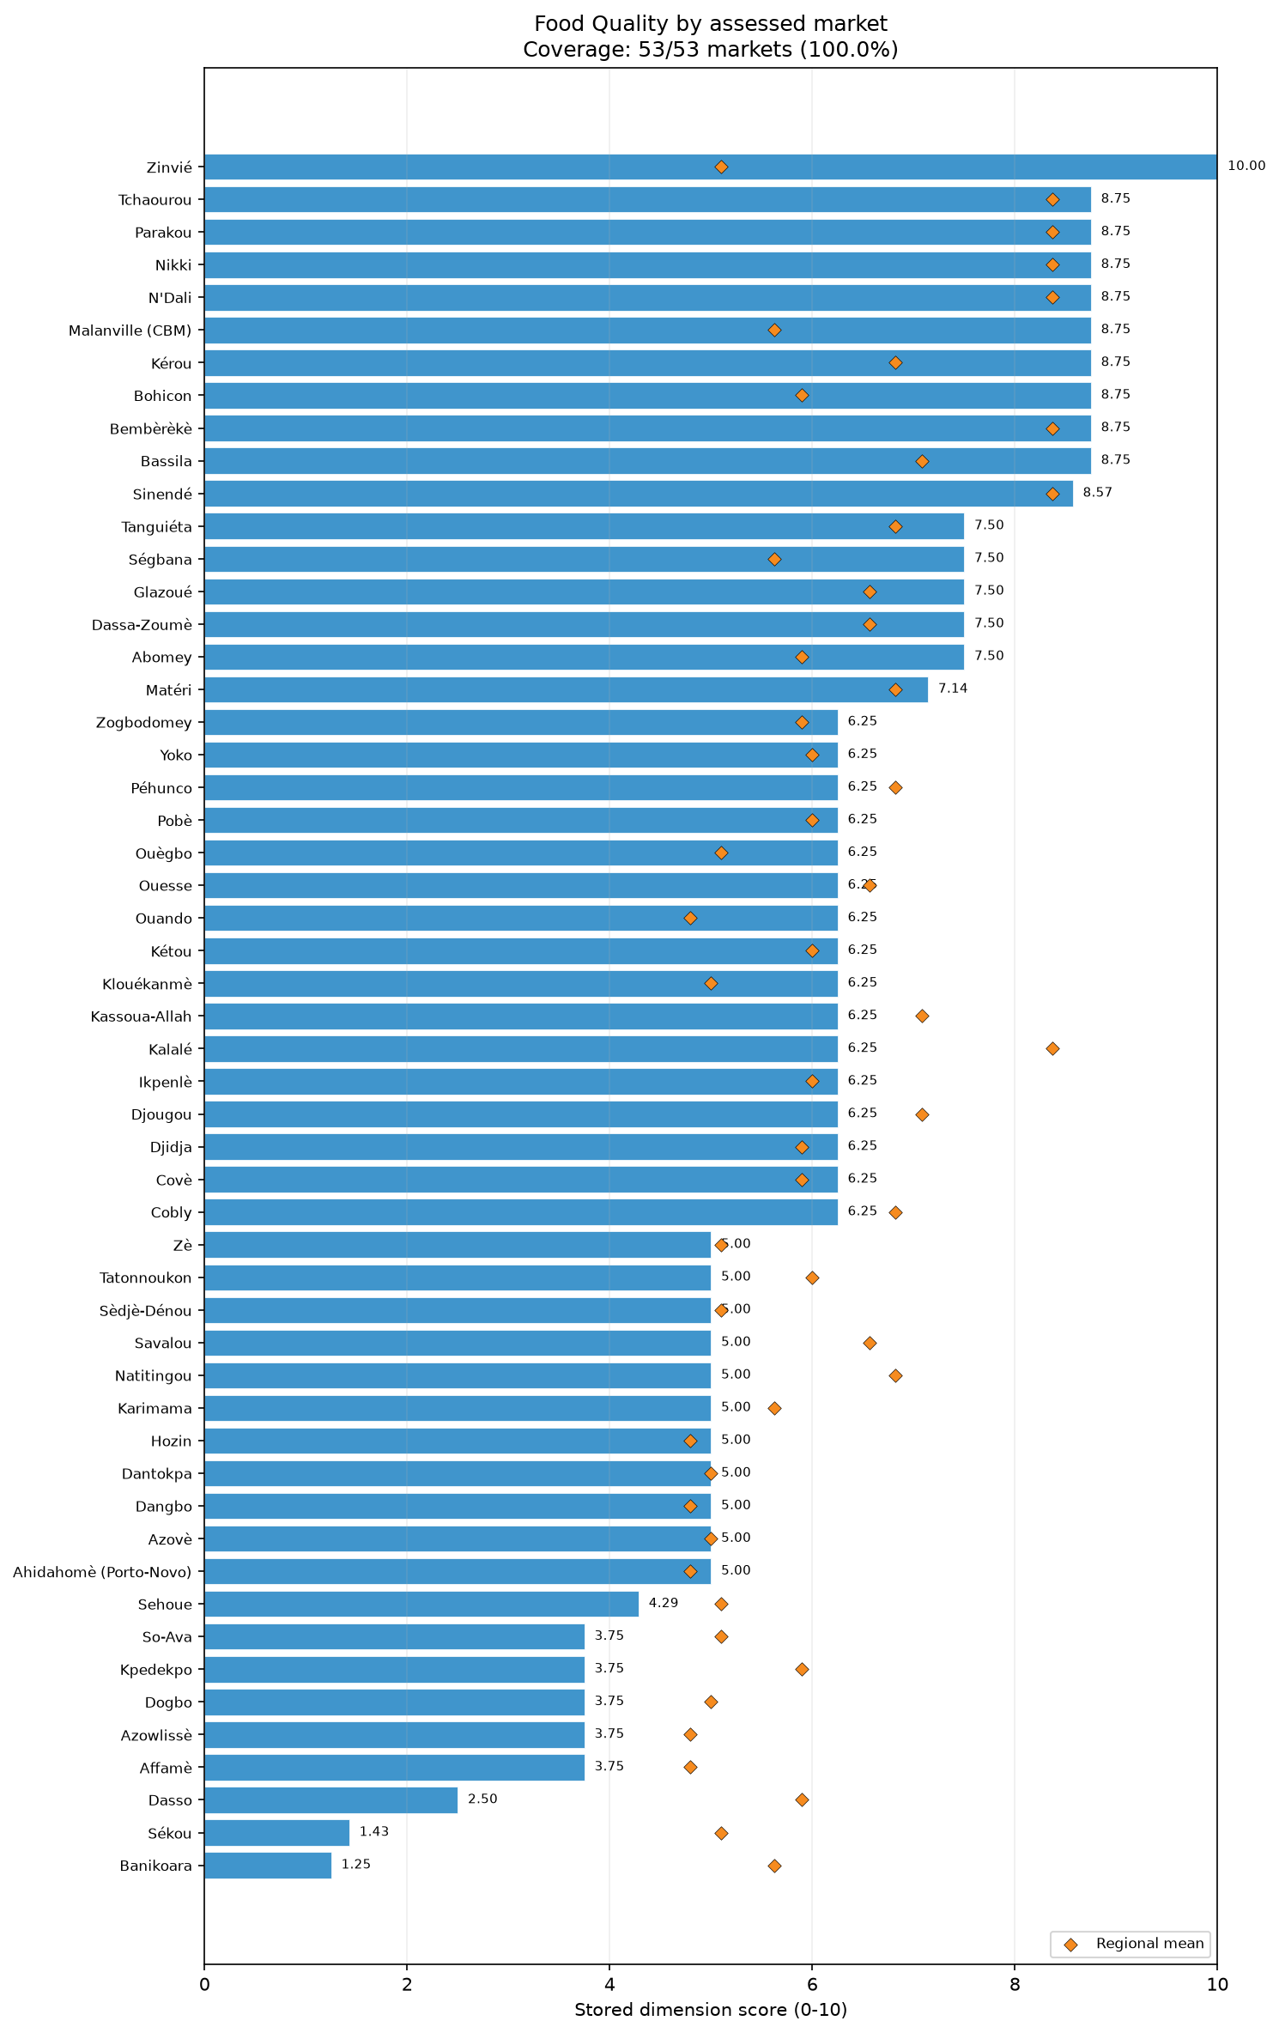
dim food quality bars
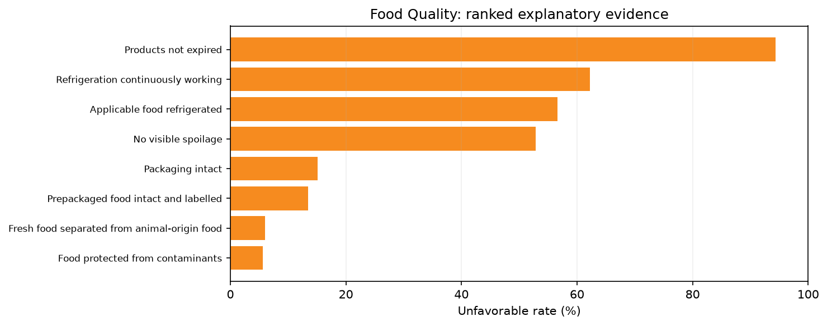
priority food quality drivers

Access & Protection
The Access & Protection dimension achieved exceptionally high scores across the 53 assessed markets in Benin, recording an unweighted mean score of 9.36/10. The median score was a perfect 10.00/10, with all markets scoring at or below the median. Fourteen markets scored below 10/10, and only three scored below 6/10, reflecting an overwhelmingly accessible and secure market environment in the locations surveyed. Regionally, Borgou, Donga, Littoral, and Oueme all achieved maximum scores of 10.00/10, while Atlantique recorded the minimum at 7.86/10. The dimension consists of two highly performing subsections: Protection and security (9.53/10) and Physical access (9.18/10). These results portray a market environment where physical reachability and personal safety are generally well maintained, despite some localized seasonal and security challenges.
The Protection and security subsection indicates a remarkably secure environment for market actors within the immediate assessed locations. The unweighted mean of market-level rates for the absence of social barriers was 98.1%. The absence of general security issues was recorded at 96.2%, and the absence of physical threats stood at 92.5%. These high rates suggest that traders and consumers can interact freely without significant fear of targeted violence, extortion, or social exclusion within the market perimeters themselves.
The Physical access subsection also demonstrated strong integration. An unweighted mean of market-level rates of 100% reported no disaster-related access limitations. Furthermore, 92.5% of the rates indicated that markets were not far from a major road network, facilitating the transport of goods and people. However, seasonal access difficulties presented a slight limitation, with 79.2% reporting no seasonal access difficulty (meaning roughly 20% face seasonal hurdles). This aligns with contextual evidence detailing recurrent flooding in southern and riverine areas, which periodically coincides with disruptions to mobility and access [S3].
It is important to contrast the high scores in the assessed markets with the broader contextual reality of Benin. External reports emphasize that since 2019, violent extremist activity from neighboring Burkina Faso and Niger has increasingly affected the northern border departments of Alibori and Atacora, driving internal displacement and restricting wider agricultural and market mobility [S1, S3, S4]. The high scores achieved in these regions reflect the security of the specific market sites assessed rather than the broader hinterlands. Limitations to this assessment include its unweighted nature, meaning it is not a population-representative estimate. The data represent a snapshot in time of the included markets. The strong performance across both subsections indicates a stable baseline, though ongoing situational monitoring remains essential. Feasibility assessments of alternative supply routes are recommended for markets experiencing recurring seasonal isolation. Recommendations include continued monitoring of market security in northern border areas, and further consultation regarding seasonal access barriers to observe whether trade remains uninterrupted during periods of heavy rainfall.
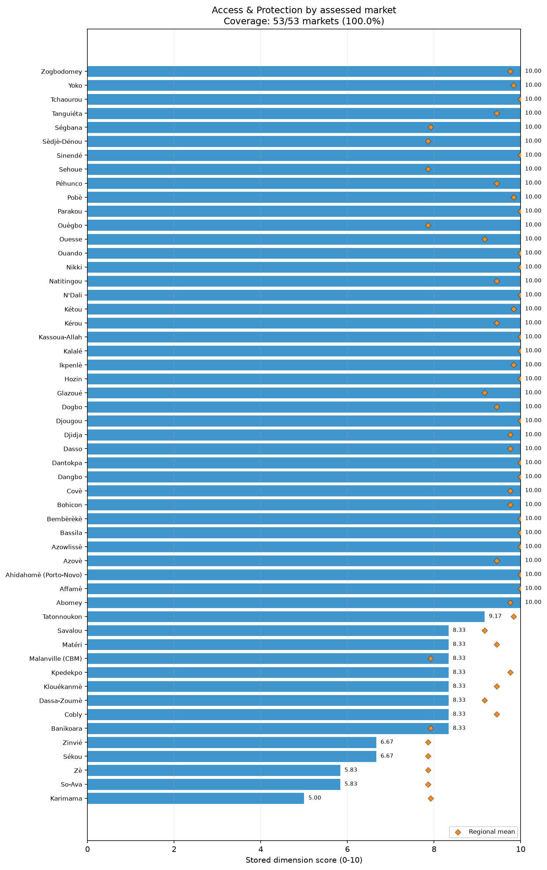
dim access and protection bars

Selected markets

Sékou
Sékou recorded an overall MFI score of 3.81. The priority constraints are Food Quality, Service, and Infrastructure. Food Quality is the weakest dimension; only 1 out of 7 applicable quality conditions were satisfied. The condition recorded for this market was uniformly unfavorable (1.0) for continuous refrigeration, absence of visible spoilage, unexpired products, and intact packaging. Service scored 3.33, driven by a checkout services score of 3.33 and a shopping services score of 3.33. The proportion of surveyed traders in this market reporting the unfavorable condition was 1.0 for automatic itemized receipts and visible price tags, and 0.91 for both checkout waits below ten minutes and remote purchase availability. Infrastructure scored 3.57, with condition at 3.33 and features at 3.75. The condition recorded for this market was unfavorable (1.0) for good infrastructure condition, closed sewage systems, reliable communication networks, and uninterrupted electricity. Recommendations: Further consultation with traders is requested to understand the barriers to maintaining food quality and basic service provision. Monitoring of infrastructure deficits is advised. Limitations: All summaries are unweighted descriptions of included assessed markets and are not population-representative estimates. Furthermore, the processed data do not provide reliable item-specific trader denominators.

Ouègbo
Ouègbo recorded an overall MFI score of 3.83. The primary constraints are Service, Infrastructure, and Food Quality. Service received a score of 0.0, reflecting absolute limits in checkout services (0.0) and shopping services (0.0). The proportion of surveyed traders in this market reporting the unfavorable condition was 1.0 for automatic itemized receipts, short checkout waits, and remote purchase availability, alongside 0.96 for visible price tags. Infrastructure scored 2.14, with a condition score of 3.33 and a features score of 1.25. The condition recorded for this market was unfavorable (1.0) for good condition, closed sewage systems, communication networks, and shelter. For Food Quality, 5 out of 8 applicable quality conditions were satisfied. The condition recorded for this market was unfavorable (1.0) for continuous refrigeration, absence of expiry, and absence of visible spoilage, though food protection from contaminants faced no issues (0.0). Recommendations: Feasibility assessments concerning infrastructure development and trader service constraints are requested to guide future engagement. Limitations: All summaries are unweighted descriptions of assessed markets and are not population-representative estimates. The processed data do not provide reliable item-specific trader denominators.

Dangbo
Dangbo achieved an overall MFI score of 4.43. The priority dimensions of concern are Service, Infrastructure, Price, and Food Quality. Service scored 1.67, with checkout services at 0.0 and shopping services at 3.33. The proportion of surveyed traders in this market reporting the unfavorable condition was 1.0 for automatic receipts and short checkout waits, and 0.92 for both multiple forms of payment and remote purchase. Infrastructure scored 4.29, with condition at 1.67 and features at 6.25. The condition recorded for this market was unfavorable (1.0) for good condition, poor condition, closed sewage, and electricity. Price scored 5.0, influenced by a stability score of 0.0; the proportion of surveyed traders reporting the unfavorable condition for cereal food and other food stability was 1.0. For Food Quality, 4 out of 8 applicable quality conditions were satisfied, where the condition recorded for this market was unfavorable (1.0) for continuous refrigeration, expiry, no spoilage, and general refrigeration. Recommendations: Consult traders on pricing volatility and the barriers limiting food preservation. Limitations: Results are unweighted descriptions of included assessed markets, not population-representative estimates, and lack item-specific trader denominators.

Banikoara
Banikoara recorded an overall MFI score of 4.45. Key weaknesses are concentrated in Food Quality, Service, and Price. For Food Quality, 1 out of 8 applicable quality conditions were satisfied. The condition recorded for this market was unfavorable (1.0) across continuous refrigeration, products not expired, no visible spoilage, and intact packaging. Service scored 5.0, with checkout services at 3.33 and shopping services at 6.67. The proportion of surveyed traders in this market reporting the unfavorable condition was 1.0 for automatic itemized receipts, short checkout waits, and visible price tags. Price scored 5.83, heavily impacted by a stability score of 1.67. The proportion of surveyed traders in this market reporting the unfavorable condition for price stability was 0.75 for cereal food, 0.67 for other food, and 0.50 for non-food items. Contextually, rising insecurity disrupts livelihoods in Alibori, which is a regional dynamic [S3]. Recommendations: Verify food handling practices and monitor price stability in cereal categories. Limitations: Summaries are unweighted descriptions of included assessed markets and are not population-representative estimates, and item-specific trader denominators are unavailable.

Savalou
Savalou registered an overall MFI score of 4.46. Constraints are primarily observed in Infrastructure, Service, and Food Quality. Infrastructure scored 1.43, with condition scoring 0.0 and features scoring 2.50. For infrastructure condition, the market lacked good condition (1.0 unfavorable rate) and explicitly exhibited poor condition (1.0 unfavorable rate). Furthermore, the condition recorded for features was unfavorable (1.0) for closed sewage systems and uninterrupted electricity. Service scored 3.33 across both checkout and shopping subsections. The proportion of surveyed traders in this market reporting the unfavorable condition was 1.0 for automatic receipts, remote purchase, and visible prices, and 0.75 for multiple forms of payment. For Food Quality, 4 out of 8 applicable quality conditions were satisfied. The condition recorded for this market was uniformly unfavorable (1.0) for continuous refrigeration, unexpired products, no visible spoilage, and applicable food refrigerated. Recommendations: Conduct further monitoring of physical market infrastructure and investigate barriers limiting the modernization of trader services. Limitations: All summaries are unweighted descriptions of included assessed markets and are not population-representative estimates. The processed data do not provide reliable item-specific trader denominators.

Dogbo
Dogbo attained an overall MFI score of 4.48. Priority constraints are evident in Service, Food Quality, and Infrastructure. Service is the lowest-performing dimension at 1.67, with checkout services scoring 0.0 and shopping services at 3.33. The proportion of surveyed traders in this market reporting the unfavorable condition was 1.0 for automatic itemized receipts, short checkout waits, and remote purchase availability, and 0.92 for visible price tags. For Food Quality, 3 out of 8 applicable quality conditions were satisfied. The condition recorded for this market was unfavorable (1.0) for continuous refrigeration, products not expired, food protected from contaminants, and applicable food refrigerated. Infrastructure scored 4.29, with condition at 6.67 and features at 2.50. The condition recorded for this market indicated unfavorable states (1.0) for poor condition, closed sewage systems, reliable communication networks, and uninterrupted electricity. Recommendations: Further verification is requested to understand the factors limiting basic service provision and food preservation standards. Limitations: All summaries are unweighted descriptions of included assessed markets and are not population-representative estimates. Furthermore, item-specific trader denominators are unavailable.

Hozin
Hozin reported an overall MFI score of 4.55, facing primary challenges in Service, Price, and Food Quality. Service scored 1.67, with checkout services scoring 0.0 and shopping services at 3.33. The proportion of surveyed traders in this market reporting the unfavorable condition was 1.0 for automatic itemized receipts, multiple forms of payment, short checkout waits, and remote purchase availability. Price scored 5.0, driven by a stability score of 0.0. The proportion of surveyed traders reporting the unfavorable condition for price stability and predictability was 1.0 across cereal food, non-food items, and other food. For Food Quality, 4 out of 8 applicable quality conditions were satisfied. The condition recorded for this market was unfavorable (1.0) for continuous refrigeration, expiry, no visible spoilage, and applicable food refrigerated. Recommendations: Consult traders regarding the underlying mechanisms of price instability and the physical barriers to effective food refrigeration. Limitations: All summaries are unweighted descriptions of assessed markets rather than population-representative estimates, and item-specific trader denominators remain unavailable.

Djidja
Djidja recorded an overall MFI score of 4.60. Market weaknesses center on Service, Infrastructure, and Competition. Service scored 1.67, with checkout services at 0.0 and shopping services at 3.33. The proportion of surveyed traders in this market reporting the unfavorable condition was 1.0 for automatic receipts, remote purchase, and visible prices, and 0.90 for multiple forms of payment. Infrastructure scored 4.29, with a condition score of 3.33 and features at 5.0. The condition recorded for this market was unfavorable (1.0) for good condition, closed sewage systems, shelter, and walkways and emergency exits. Competition scored 5.83, constrained by a concentration score of 3.33 and a monopoly score of 8.33. The condition recorded for this market indicated an unfavorable rate of 1.0 for sufficient trader competition in cereal food and non-food items, and for the absence of single-trader control in non-food items. Recommendations: Assess the factors restricting trader competition in core commodity categories and investigate infrastructure deficiencies. Limitations: Summaries are unweighted descriptions of assessed markets and are not population-representative estimates; reliable item-specific trader denominators are also absent.

Sèdjè-Dénou
Sèdjè-Dénou achieved an overall MFI score of 4.61. The market is primarily constrained by Service, Price, and Food Quality. Service scored 1.67, with checkout services at 0.0 and shopping services at 3.33. The proportion of surveyed traders in this market reporting the unfavorable condition was 1.0 across automatic itemized receipts, short checkout waits, remote purchase availability, and visible price tags. Price scored 5.0, heavily affected by a stability score of 0.0. The proportion of surveyed traders reporting the unfavorable condition for price stability was 1.0 for cereal food and other food, and 0.75 for non-food items. For Food Quality, 4 out of 8 applicable quality conditions were satisfied. The condition recorded for this market was uniformly unfavorable (1.0) for continuous refrigeration, products not expired, no visible spoilage, and applicable food refrigerated. Recommendations: Monitor market price volatility and request further consultation on barriers preventing the provision of continuous refrigeration. Limitations: All summaries are unweighted descriptions of included assessed markets, not population-representative estimates, and lack reliable item-specific trader denominators.

Péhunco
Péhunco recorded an overall MFI score of 4.62. Priority constraints include Service, Infrastructure, and Price. Service scored 1.67, with checkout services at 0.0 and shopping services at 3.33. The proportion of surveyed traders in this market reporting the unfavorable condition was 1.0 for automatic receipts, short waits, and visible prices, while remote purchase reached 0.91. Infrastructure scored 4.29, with condition at 3.33 and features at 5.0. The condition recorded for this market was unfavorable (1.0) for good condition, closed sewage systems, uninterrupted electricity, and walkways and emergency exits. Price scored 5.83, limited by a stability score of 1.67. The proportion of surveyed traders reporting the unfavorable condition for price stability was 0.75 for both cereal food and other food, and 0.50 for non-food items. These dynamics occur in Atakora, an area experiencing rising insecurity [S3]. Recommendations: Verify the infrastructural challenges and monitor price stability issues, particularly for cereal food. Limitations: Findings are unweighted descriptions of assessed markets and do not serve as representative country estimates.

Kérou
Kérou registered an overall MFI score of 4.63. The weakest dimensions are Service, Infrastructure, and Price. Service scored 1.67, with checkout services at 0.0 and shopping services at 3.33. The proportion of surveyed traders in this market reporting the unfavorable condition was 1.0 for automatic receipts and visible prices, and 0.92 for both short checkout wait and remote purchase. Infrastructure scored 3.57, with condition at 3.33 and features at 3.75. The condition recorded for this market was unfavorable (1.0) for good condition, closed sewage systems, reliable electricity, and shelter. Price scored 5.0, constrained by a stability score of 0.0. The proportion of surveyed traders reporting the unfavorable condition for price stability was 1.0 for cereal food and non-food items, and 0.80 for other food. Kérou is located in Atakora, where regional insecurity is reported [S3]. Recommendations: Further assessment of physical market infrastructure and price volatility mechanisms is requested. Limitations: All summaries are unweighted descriptions of assessed markets and are not population-representative estimates.

Sinendé
Sinendé attained an overall MFI score of 4.70. Constraints are led by Infrastructure, Competition, and Service. Infrastructure is the weakest dimension at 1.43, with condition at 0.0 and features at 2.50. The condition recorded for this market was unfavorable (1.0) for good condition, poor condition, closed sewage, and electricity. Competition scored 4.17, driven by a concentration score of 1.67 and a monopoly score of 6.67. The condition recorded for this market indicated unfavorable rates (1.0) for sufficient trader competition in cereal food and other food, and for the absence of single-trader control in other food. Service scored 5.0, with checkout at 6.67 and shopping at 3.33. The proportion of surveyed traders reporting the unfavorable condition was 1.0 for automatic itemized receipts, remote purchase availability, and visible price tags. Recommendations: Conduct feasibility assessments concerning infrastructure upgrades and investigate barriers preventing broader market competition. Limitations: Summaries represent unweighted descriptions of included assessed markets, are not population-representative estimates, and lack reliable item-specific trader denominators.

Sehoue
Sehoue recorded an overall MFI score of 4.72. The priority constraints for this market are Service, Infrastructure, and Food Quality. Service scored 1.67, with checkout services at 0.0 and shopping services at 3.33. The proportion of surveyed traders in this market reporting the unfavorable condition was 1.0 for automatic receipts, short checkout waits, and remote purchase, and 0.83 for visible prices. Infrastructure scored 3.57, constrained by a condition score of 8.33 and a features score of 0.0. The condition recorded for this market was unfavorable (1.0) for closed sewage systems, reliable communication networks, uninterrupted electricity, and shelter. For Food Quality, 3 out of 7 applicable quality conditions were satisfied. The condition recorded for this market was uniformly unfavorable (1.0) for continuous refrigeration, products not expired, no visible spoilage, and intact packaging. Recommendations: Monitor the constraints on basic physical infrastructure and consult traders regarding the systemic barriers to improved food handling practices. Limitations: All summaries are unweighted descriptions of assessed markets rather than population-representative estimates, and the data do not supply reliable item-specific trader denominators.

Dasso
Dasso achieved an overall MFI score of 4.83. Market weaknesses include Food Quality, Service, Assortment, and Price. For Food Quality, 2 out of 8 applicable quality conditions were satisfied. The condition recorded for this market was unfavorable (1.0) for continuous refrigeration, unexpired products, no visible spoilage, and intact packaging. Service scored 3.33, with checkout and shopping both at 3.33. The proportion of surveyed traders reporting the unfavorable condition was 1.0 for automatic receipts and remote purchase, and 0.92 for visible prices. Assortment scored 5.0, limited by an assortment depth score of 0.0 and an assortment breadth score of 7.14. Explaining the breadth score, the proportion of surveyed traders reporting the unfavorable condition was 1.0 for health and shelter non-food items, and specific cereals like barley, cassava, and other cereals. Price scored 5.0, with stability at 0.0. Recommendations: Investigate the drivers limiting assortment depth and the obstacles to consistent food quality and preservation. Limitations: Findings are unweighted descriptions of assessed markets, not representative country estimates, and item-specific trader denominators are unavailable.

Zinvié
Zinvié registered an overall MFI score of 4.98. The market faces constraints in Service, Price, and Access & Protection. Service scored 1.67, with checkout services at 0.0 and shopping services at 3.33. The proportion of surveyed traders in this market reporting the unfavorable condition was 1.0 for automatic receipts, short checkout waits, remote purchase, and visible prices. Price scored 6.67, with stability at 3.33. The proportion of surveyed traders reporting the unfavorable condition for price stability and predictability was 0.75 for cereal food and non-food items. Access & Protection scored 6.67, with protection at 5.0. The condition recorded for this market was unfavorable (1.0) regarding the absence of general security issues and proximity to a major road network. Recommendations: Monitor security and physical access conditions closely. Further verification of the barriers to market price stability is requested. Limitations: All summaries are unweighted descriptions of included assessed markets, not population-representative estimates, and item-specific trader denominators are unavailable.

Analytical annex: complete dimension evidence

Assortment

Assortment: unweighted score distribution (0–10)
Statistic | Score
Mean | 7.75
Median | 8.00
Minimum | 3.00
Maximum | 10.00
Q1 | 7.00
Q3 | 9.00
Iqr | 2.00
Score Range | 7.00

Assortment: local extremes, including all ties
Market | Score /10 | Comparison
Affamè | 3.00 | Minimum
Cobly | 3.00 | Minimum
Matéri | 3.00 | Minimum
Bassila | 10.00 | Maximum
Bembèrèkè | 10.00 | Maximum
Klouékanmè | 10.00 | Maximum
Savalou | 10.00 | Maximum
Sinendé | 10.00 | Maximum
Tchaourou | 10.00 | Maximum

Assortment: complete regional comparisons
Region | Mean /10 | Markets
Alibori | 9.00 | 4
Atakora | 6.17 | 6
Atlantique | 7.43 | 7
Borgou | 9.43 | 7
Collines | 8.00 | 4
Couffo | 8.00 | 3
Donga | 9.00 | 3
Littoral | 7.00 | 1
Oueme | 7.00 | 6
Plateau | 8.00 | 5
Zou | 6.86 | 7

Assortment: Official subsections and special scoring components
Indicator | Raw mean | Normalized /10 | Adverse rate | Markets | Evidence / applicability
Assortment depth | 3.06 | 6.86 | -205.7% | 53/53 | Observed
Assortment breadth | 6.70 | 8.14 | -569.8% | 53/53 | Observed

Assortment: Fixed drivers and product indicators
Indicator | Raw mean | Normalized /10 | Adverse rate | Markets | Evidence / applicability
NFI - health | 0.23 | 2.26 | 77.4% | 53/53 | Observed
Cereal assortment - Cassava | 0.00 | 0.00 | 100.0% | 53/53 | Observed
NFI - shelter | 0.75 | 7.55 | 24.5% | 53/53 | Observed
Cereal assortment - Barley | 0.00 | 0.05 | 99.5% | 53/53 | Observed
NFI - education | 0.85 | 8.49 | 15.1% | 53/53 | Observed
Cereal assortment - Other cereal | 0.02 | 0.24 | 97.6% | 53/53 | Observed
NFI - communication | 0.91 | 9.06 | 9.4% | 53/53 | Observed
Cereal assortment - Bread | 0.03 | 0.28 | 97.2% | 53/53 | Observed; not selected by item eligibility rule
NFI - WASH | 0.96 | 9.62 | 3.8% | 53/53 | Observed
Other food assortment - Other non-cereal food | 0.10 | 1.04 | 89.6% | 53/53 | Observed
Cereal food | 1.00 | 10.00 | 0.0% | 53/53 | Observed
NFI - household items | 1.00 | 10.00 | 0.0% | 53/53 | Observed
Other food | 1.00 | 10.00 | 0.0% | 53/53 | Observed
Other food assortment - Meat, fish and eggs | 0.13 | 1.35 | 86.5% | 53/53 | Observed
Cereal assortment - Pasta | 0.14 | 1.36 | 86.4% | 53/53 | Observed; not selected by item eligibility rule
Cereal assortment - Wheat | 0.17 | 1.75 | 82.5% | 53/53 | Observed; not selected by item eligibility rule
Other food assortment - Roots and tubers | 0.18 | 1.79 | 82.1% | 53/53 | Observed
Other food assortment - Fruits and vegetables | 0.21 | 2.09 | 79.1% | 53/53 | Observed; not selected by item eligibility rule
Other food assortment - Legumes, nuts and seeds | 0.25 | 2.48 | 75.2% | 53/53 | Observed; not selected by item eligibility rule
Cereal assortment - Flour | 0.29 | 2.90 | 71.0% | 53/53 | Observed; not selected by item eligibility rule
Other food assortment - Milk and dairy products | 0.30 | 2.96 | 70.4% | 53/53 | Observed; not selected by item eligibility rule
Cereal assortment - Millet | 0.33 | 3.27 | 67.3% | 53/53 | Observed; not selected by item eligibility rule
Other food assortment - Oils and fats | 0.37 | 3.69 | 63.1% | 53/53 | Observed; not selected by item eligibility rule
Other food assortment - Herbs, condiments and spices | 0.43 | 4.27 | 57.3% | 53/53 | Observed; not selected by item eligibility rule
Cereal assortment - Sorghum | 0.52 | 5.22 | 47.8% | 53/53 | Observed; not selected by item eligibility rule
Cereal assortment - Rice | 0.57 | 5.66 | 43.4% | 53/53 | Observed; not selected by item eligibility rule
Cereal assortment - Maize | 0.76 | 7.61 | 23.9% | 53/53 | Observed; not selected by item eligibility rule
SKU depth: 1-50 | 0.25 | 2.45 | Not directional | 53/53 | Observed
SKU depth: 201-1,000 | 0.23 | 2.26 | Not directional | 53/53 | Observed
SKU depth: 51-200 | 0.42 | 4.15 | Not directional | 53/53 | Observed
SKU depth: more than 1,000 | 0.11 | 1.13 | Not directional | 53/53 | Observed
33 of 53 assessed markets scored at or below the median of 8.00/10 for Assortment.
Atakora had the lowest unweighted regional mean Assortment score (6.17/10).
Borgou had the highest unweighted regional mean Assortment score (9.43/10).

Availability

Availability: unweighted score distribution (0–10)
Statistic | Score
Mean | 9.81
Median | 10.00
Minimum | 5.00
Maximum | 10.00
Q1 | 10.00
Q3 | 10.00
Iqr | 0.00
Score Range | 5.00

Availability: local extremes, including all ties
Market | Score /10 | Comparison
Sékou | 5.00 | Minimum
Abomey | 10.00 | Maximum
Affamè | 10.00 | Maximum
Ahidahomè (Porto-Novo) | 10.00 | Maximum
Azovè | 10.00 | Maximum
Azowlissè | 10.00 | Maximum
Banikoara | 10.00 | Maximum
Bassila | 10.00 | Maximum
Bembèrèkè | 10.00 | Maximum
Bohicon | 10.00 | Maximum
Cobly | 10.00 | Maximum
Covè | 10.00 | Maximum
Dangbo | 10.00 | Maximum
Dantokpa | 10.00 | Maximum
Dassa-Zoumè | 10.00 | Maximum
Dasso | 10.00 | Maximum
Djidja | 10.00 | Maximum
Djougou | 10.00 | Maximum
Dogbo | 10.00 | Maximum
Glazoué | 10.00 | Maximum
Hozin | 10.00 | Maximum
Ikpenlè | 10.00 | Maximum
Kalalé | 10.00 | Maximum
Karimama | 10.00 | Maximum
Kassoua-Allah | 10.00 | Maximum
Klouékanmè | 10.00 | Maximum
Kpedekpo | 10.00 | Maximum
Kérou | 10.00 | Maximum
Kétou | 10.00 | Maximum
Malanville (CBM) | 10.00 | Maximum
Matéri | 10.00 | Maximum
N'Dali | 10.00 | Maximum
Natitingou | 10.00 | Maximum
Nikki | 10.00 | Maximum
Ouando | 10.00 | Maximum
Ouègbo | 10.00 | Maximum
Parakou | 10.00 | Maximum
Pobè | 10.00 | Maximum
Péhunco | 10.00 | Maximum
Savalou | 10.00 | Maximum
Sehoue | 10.00 | Maximum
Sinendé | 10.00 | Maximum
So-Ava | 10.00 | Maximum
Sèdjè-Dénou | 10.00 | Maximum
Ségbana | 10.00 | Maximum
Tanguiéta | 10.00 | Maximum
Tatonnoukon | 10.00 | Maximum
Tchaourou | 10.00 | Maximum
Yoko | 10.00 | Maximum
Zinvié | 10.00 | Maximum
Zè | 10.00 | Maximum

Availability: complete regional comparisons
Region | Mean /10 | Markets
Alibori | 10.00 | 4
Atakora | 10.00 | 6
Atlantique | 9.29 | 7
Borgou | 10.00 | 7
Collines | 9.58 | 4
Couffo | 10.00 | 3
Donga | 10.00 | 3
Littoral | 10.00 | 1
Oueme | 10.00 | 6
Plateau | 10.00 | 5
Zou | 9.52 | 7

Availability: Official subsections and special scoring components
Indicator | Raw mean | Normalized /10 | Adverse rate | Markets | Evidence / applicability
Absence of imminent runout | 5.87 | 9.78 | -486.8% | 53/53 | Observed
Absence of scarcity | 5.91 | 9.84 | -490.6% | 53/53 | Observed

Availability: Fixed drivers and product indicators
Indicator | Raw mean | Normalized /10 | Adverse rate | Markets | Evidence / applicability
Not running out - Other food | 0.90 | 8.95 | 10.5% | 53/53 | Observed
Runout problem rate - NFI: Health | 0.33 | 3.33 | 33.3% | 3/53 | Observed; applicability unknown elsewhere; not selected by item eligibility rule
Scarcity problem rate - NFI: Health | 0.33 | 3.33 | 33.3% | 3/53 | Observed; applicability unknown elsewhere; not selected by item eligibility rule
Not running out - Cereal food | 0.92 | 9.21 | 7.9% | 53/53 | Observed
Runout problem rate - Other food: Other non-cereal food | 0.14 | 1.43 | 14.3% | 14/53 | Observed; applicability unknown elsewhere; not selected by item eligibility rule
Not scarce - Other food | 0.93 | 9.31 | 6.9% | 53/53 | Observed
Not scarce - Cereal food | 0.94 | 9.37 | 6.3% | 53/53 | Observed
Scarcity problem rate - NFI: Communication | 0.12 | 1.18 | 11.8% | 17/53 | Observed; applicability unknown elsewhere; not selected by item eligibility rule
Not scarce - Non-food items | 0.95 | 9.51 | 4.9% | 53/53 | Observed
Scarcity problem rate - Cereal: Wheat | 0.11 | 1.09 | 10.9% | 23/53 | Observed; applicability unknown elsewhere; not selected by item eligibility rule
Not running out - Non-food items | 0.95 | 9.53 | 4.7% | 53/53 | Observed
Scarcity problem rate - Other food: Other non-cereal food | 0.09 | 0.89 | 8.9% | 14/53 | Observed; applicability unknown elsewhere; not selected by item eligibility rule
Runout problem rate - Cereal: Wheat | 0.09 | 0.87 | 8.7% | 23/53 | Observed; applicability unknown elsewhere; not selected by item eligibility rule
Scarcity problem rate - NFI: Education | 0.07 | 0.71 | 7.1% | 14/53 | Observed; applicability unknown elsewhere; not selected by item eligibility rule
Runout problem rate - Other food: Herbs, condiments and spices | 0.06 | 0.64 | 6.4% | 47/53 | Observed; applicability unknown elsewhere; not selected by item eligibility rule
Runout problem rate - Other food: Fruits and vegetables | 0.06 | 0.62 | 6.2% | 32/53 | Observed; applicability unknown elsewhere; not selected by item eligibility rule
Runout problem rate - Cereal: Sorghum | 0.06 | 0.60 | 6.0% | 47/53 | Observed; applicability unknown elsewhere; not selected by item eligibility rule
Runout problem rate - NFI: Communication | 0.06 | 0.59 | 5.9% | 17/53 | Observed; applicability unknown elsewhere; not selected by item eligibility rule
Runout problem rate - Cereal: Rice | 0.04 | 0.43 | 4.3% | 49/53 | Observed; applicability unknown elsewhere; not selected by item eligibility rule
Runout problem rate - Cereal: Maize | 0.04 | 0.42 | 4.2% | 53/53 | Observed; not selected by item eligibility rule
Runout problem rate - Other food: Meat, fish and eggs | 0.04 | 0.38 | 3.8% | 26/53 | Observed; applicability unknown elsewhere; not selected by item eligibility rule
Scarcity problem rate - Cereal: Millet | 0.03 | 0.34 | 3.4% | 39/53 | Observed; applicability unknown elsewhere; not selected by item eligibility rule
Runout problem rate - Other food: Milk and dairy products | 0.03 | 0.31 | 3.1% | 32/53 | Observed; applicability unknown elsewhere; not selected by item eligibility rule
Scarcity problem rate - Other food: Milk and dairy products | 0.03 | 0.31 | 3.1% | 32/53 | Observed; applicability unknown elsewhere; not selected by item eligibility rule
Runout problem rate - Cereal: Millet | 0.03 | 0.30 | 3.0% | 39/53 | Observed; applicability unknown elsewhere; not selected by item eligibility rule
Runout problem rate - NFI: Shelter | 0.03 | 0.29 | 2.9% | 17/53 | Observed; applicability unknown elsewhere; not selected by item eligibility rule
Scarcity problem rate - Cereal: Sorghum | 0.03 | 0.28 | 2.8% | 47/53 | Observed; applicability unknown elsewhere; not selected by item eligibility rule
Scarcity problem rate - Other food: Legumes, nuts and seeds | 0.03 | 0.28 | 2.8% | 36/53 | Observed; applicability unknown elsewhere; not selected by item eligibility rule
Scarcity problem rate - NFI: WASH | 0.03 | 0.25 | 2.5% | 40/53 | Observed; applicability unknown elsewhere; not selected by item eligibility rule
Scarcity problem rate - Other food: Herbs, condiments and spices | 0.02 | 0.21 | 2.1% | 47/53 | Observed; applicability unknown elsewhere; not selected by item eligibility rule
Runout problem rate - Other food: Roots and tubers | 0.02 | 0.19 | 1.9% | 27/53 | Observed; applicability unknown elsewhere; not selected by item eligibility rule
Scarcity problem rate - Cereal: Rice | 0.02 | 0.15 | 1.5% | 49/53 | Observed; applicability unknown elsewhere; not selected by item eligibility rule
Scarcity problem rate - NFI: Household items | 0.01 | 0.14 | 1.4% | 52/53 | Observed; applicability unknown elsewhere; not selected by item eligibility rule
Scarcity problem rate - Other food: Oils and fats | 0.01 | 0.14 | 1.4% | 37/53 | Observed; applicability unknown elsewhere; not selected by item eligibility rule
Scarcity problem rate - Cereal: Maize | 0.01 | 0.14 | 1.4% | 53/53 | Observed; not selected by item eligibility rule
Runout problem rate - Other food: Oils and fats | 0.01 | 0.09 | 0.9% | 37/53 | Observed; applicability unknown elsewhere; not selected by item eligibility rule
Runout problem rate - Cereal: Flour | 0.01 | 0.07 | 0.7% | 34/53 | Observed; applicability unknown elsewhere; not selected by item eligibility rule
Runout problem rate - Other food: Legumes, nuts and seeds | 0.01 | 0.07 | 0.7% | 36/53 | Observed; applicability unknown elsewhere; not selected by item eligibility rule
Runout problem rate - NFI: Household items | 0.00 | 0.05 | 0.5% | 52/53 | Observed; applicability unknown elsewhere; not selected by item eligibility rule
Runout problem rate - Cereal: Barley | 0.00 | 0.00 | 0.0% | 1/53 | Observed; applicability unknown elsewhere; not selected by item eligibility rule
Runout problem rate - Cereal: Bread | 0.00 | 0.00 | 0.0% | 3/53 | Observed; applicability unknown elsewhere; not selected by item eligibility rule
Runout problem rate - Cereal: Other cereal | 0.00 | 0.00 | 0.0% | 5/53 | Observed; applicability unknown elsewhere; not selected by item eligibility rule
Runout problem rate - Cereal: Pasta | 0.00 | 0.00 | 0.0% | 16/53 | Observed; applicability unknown elsewhere; not selected by item eligibility rule
Runout problem rate - NFI: Education | 0.00 | 0.00 | 0.0% | 14/53 | Observed; applicability unknown elsewhere; not selected by item eligibility rule
Runout problem rate - NFI: WASH | 0.00 | 0.00 | 0.0% | 40/53 | Observed; applicability unknown elsewhere; not selected by item eligibility rule
Scarcity problem rate - Cereal: Barley | 0.00 | 0.00 | 0.0% | 1/53 | Observed; applicability unknown elsewhere; not selected by item eligibility rule
Scarcity problem rate - Cereal: Bread | 0.00 | 0.00 | 0.0% | 3/53 | Observed; applicability unknown elsewhere; not selected by item eligibility rule
Scarcity problem rate - Cereal: Flour | 0.00 | 0.00 | 0.0% | 34/53 | Observed; applicability unknown elsewhere; not selected by item eligibility rule
Scarcity problem rate - Cereal: Other cereal | 0.00 | 0.00 | 0.0% | 5/53 | Observed; applicability unknown elsewhere; not selected by item eligibility rule
Scarcity problem rate - Cereal: Pasta | 0.00 | 0.00 | 0.0% | 16/53 | Observed; applicability unknown elsewhere; not selected by item eligibility rule
Scarcity problem rate - NFI: Shelter | 0.00 | 0.00 | 0.0% | 17/53 | Observed; applicability unknown elsewhere; not selected by item eligibility rule
Scarcity problem rate - Other food: Fruits and vegetables | 0.00 | 0.00 | 0.0% | 32/53 | Observed; applicability unknown elsewhere; not selected by item eligibility rule
Scarcity problem rate - Other food: Meat, fish and eggs | 0.00 | 0.00 | 0.0% | 26/53 | Observed; applicability unknown elsewhere; not selected by item eligibility rule
Scarcity problem rate - Other food: Roots and tubers | 0.00 | 0.00 | 0.0% | 27/53 | Observed; applicability unknown elsewhere; not selected by item eligibility rule
53 of 53 assessed markets scored at or below the median of 10.00/10 for Availability.
Atlantique had the lowest unweighted regional mean Availability score (9.29/10).
Alibori, Atakora, Borgou, Couffo, Donga, Littoral, Oueme, Plateau had the highest unweighted regional mean Availability score (10.00/10).

Price

Price: unweighted score distribution (0–10)
Statistic | Score
Mean | 8.00
Median | 9.17
Minimum | 5.00
Maximum | 10.00
Q1 | 5.00
Q3 | 10.00
Iqr | 5.00
Score Range | 5.00

Price: local extremes, including all ties
Market | Score /10 | Comparison
Affamè | 5.00 | Minimum
Ahidahomè (Porto-Novo) | 5.00 | Minimum
Azowlissè | 5.00 | Minimum
Dangbo | 5.00 | Minimum
Dassa-Zoumè | 5.00 | Minimum
Dasso | 5.00 | Minimum
Dogbo | 5.00 | Minimum
Hozin | 5.00 | Minimum
Karimama | 5.00 | Minimum
Kpedekpo | 5.00 | Minimum
Kérou | 5.00 | Minimum
Ouando | 5.00 | Minimum
Sèdjè-Dénou | 5.00 | Minimum
Zogbodomey | 5.00 | Minimum
Zè | 5.00 | Minimum
Abomey | 10.00 | Maximum
Bassila | 10.00 | Maximum
Bohicon | 10.00 | Maximum
Cobly | 10.00 | Maximum
Dantokpa | 10.00 | Maximum
Djidja | 10.00 | Maximum
Djougou | 10.00 | Maximum
Ikpenlè | 10.00 | Maximum
Kassoua-Allah | 10.00 | Maximum
Klouékanmè | 10.00 | Maximum
Kétou | 10.00 | Maximum
Malanville (CBM) | 10.00 | Maximum
Matéri | 10.00 | Maximum
N'Dali | 10.00 | Maximum
Natitingou | 10.00 | Maximum
Nikki | 10.00 | Maximum
Ouesse | 10.00 | Maximum
Ouègbo | 10.00 | Maximum
Pobè | 10.00 | Maximum
Sehoue | 10.00 | Maximum
Sinendé | 10.00 | Maximum
Ségbana | 10.00 | Maximum
Tanguiéta | 10.00 | Maximum
Tatonnoukon | 10.00 | Maximum
Yoko | 10.00 | Maximum

Price: complete regional comparisons
Region | Mean /10 | Markets
Alibori | 7.71 | 4
Atakora | 8.47 | 6
Atlantique | 7.38 | 7
Borgou | 8.93 | 7
Collines | 7.71 | 4
Couffo | 7.78 | 3
Donga | 10.00 | 3
Littoral | 10.00 | 1
Oueme | 5.00 | 6
Plateau | 10.00 | 5
Zou | 7.74 | 7

Price: Official subsections and special scoring components
Indicator | Raw mean | Normalized /10 | Adverse rate | Markets | Evidence / applicability
Price stability and predictability | 3.75 | 6.26 | -275.5% | 53/53 | Observed
Absence of recent large price increases | 5.85 | 9.75 | -484.9% | 53/53 | Observed

Price: Fixed drivers and product indicators
Indicator | Raw mean | Normalized /10 | Adverse rate | Markets | Evidence / applicability
Price stability - Other food | 0.57 | 5.66 | 43.4% | 53/53 | Observed
Price instability rate - Other food: Herbs, condiments and spices | 0.42 | 4.20 | 42.0% | 47/53 | Observed; applicability unknown elsewhere; not selected by item eligibility rule
Price stability - Non-food items | 0.59 | 5.92 | 40.8% | 53/53 | Observed
Price instability rate - NFI: Household items | 0.40 | 4.01 | 40.1% | 52/53 | Observed; applicability unknown elsewhere; not selected by item eligibility rule
Price stability - Cereal food | 0.61 | 6.09 | 39.1% | 53/53 | Observed
Price instability rate - Cereal: Flour | 0.38 | 3.75 | 37.5% | 34/53 | Observed; applicability unknown elsewhere; not selected by item eligibility rule
Price instability rate - Other food: Fruits and vegetables | 0.38 | 3.75 | 37.5% | 32/53 | Observed; applicability unknown elsewhere; not selected by item eligibility rule
Price not increased - Other food | 0.90 | 9.02 | 9.8% | 53/53 | Observed
Price not increased - Non-food items | 0.92 | 9.25 | 7.5% | 53/53 | Observed
Price instability rate - Other food: Roots and tubers | 0.37 | 3.70 | 37.0% | 27/53 | Observed; applicability unknown elsewhere; not selected by item eligibility rule
Price not increased - Cereal food | 0.93 | 9.34 | 6.6% | 53/53 | Observed
Price instability rate - NFI: WASH | 0.35 | 3.53 | 35.3% | 40/53 | Observed; applicability unknown elsewhere; not selected by item eligibility rule
Price instability rate - Cereal: Maize | 0.35 | 3.50 | 35.0% | 53/53 | Observed; not selected by item eligibility rule
Price instability rate - Other food: Legumes, nuts and seeds | 0.35 | 3.47 | 34.7% | 36/53 | Observed; applicability unknown elsewhere; not selected by item eligibility rule
Price increase rate - NFI: Health | 0.33 | 3.33 | 33.3% | 3/53 | Observed; applicability unknown elsewhere; not selected by item eligibility rule
Price instability rate - Other food: Milk and dairy products | 0.33 | 3.26 | 32.6% | 32/53 | Observed; applicability unknown elsewhere; not selected by item eligibility rule
Price instability rate - Other food: Oils and fats | 0.32 | 3.19 | 31.9% | 37/53 | Observed; applicability unknown elsewhere; not selected by item eligibility rule
Price instability rate - Cereal: Millet | 0.32 | 3.16 | 31.6% | 39/53 | Observed; applicability unknown elsewhere; not selected by item eligibility rule
Price instability rate - Cereal: Wheat | 0.31 | 3.12 | 31.2% | 23/53 | Observed; applicability unknown elsewhere; not selected by item eligibility rule
Price instability rate - Cereal: Sorghum | 0.30 | 3.03 | 30.3% | 47/53 | Observed; applicability unknown elsewhere; not selected by item eligibility rule
Price instability rate - Cereal: Pasta | 0.30 | 3.02 | 30.2% | 16/53 | Observed; applicability unknown elsewhere; not selected by item eligibility rule
Price instability rate - Cereal: Rice | 0.28 | 2.82 | 28.2% | 49/53 | Observed; applicability unknown elsewhere; not selected by item eligibility rule
Price instability rate - NFI: Shelter | 0.26 | 2.65 | 26.5% | 17/53 | Observed; applicability unknown elsewhere; not selected by item eligibility rule
Price instability rate - Other food: Meat, fish and eggs | 0.24 | 2.37 | 23.7% | 26/53 | Observed; applicability unknown elsewhere; not selected by item eligibility rule
Price instability rate - NFI: Education | 0.21 | 2.14 | 21.4% | 14/53 | Observed; applicability unknown elsewhere; not selected by item eligibility rule
Price instability rate - Cereal: Other cereal | 0.20 | 2.00 | 20.0% | 5/53 | Observed; applicability unknown elsewhere; not selected by item eligibility rule
Price instability rate - Other food: Other non-cereal food | 0.15 | 1.54 | 15.4% | 14/53 | Observed; applicability unknown elsewhere; not selected by item eligibility rule
Price increase rate - Other food: Fruits and vegetables | 0.12 | 1.25 | 12.5% | 32/53 | Observed; applicability unknown elsewhere; not selected by item eligibility rule
Price increase rate - Cereal: Wheat | 0.09 | 0.87 | 8.7% | 23/53 | Observed; applicability unknown elsewhere; not selected by item eligibility rule
Price increase rate - Other food: Roots and tubers | 0.07 | 0.74 | 7.4% | 27/53 | Observed; applicability unknown elsewhere; not selected by item eligibility rule
Price increase rate - Other food: Herbs, condiments and spices | 0.06 | 0.64 | 6.4% | 47/53 | Observed; applicability unknown elsewhere; not selected by item eligibility rule
Price increase rate - NFI: Communication | 0.06 | 0.59 | 5.9% | 17/53 | Observed; applicability unknown elsewhere; not selected by item eligibility rule
Price increase rate - NFI: Shelter | 0.06 | 0.59 | 5.9% | 17/53 | Observed; applicability unknown elsewhere; not selected by item eligibility rule
Price instability rate - NFI: Communication | 0.06 | 0.59 | 5.9% | 17/53 | Observed; applicability unknown elsewhere; not selected by item eligibility rule
Price increase rate - NFI: Household items | 0.06 | 0.58 | 5.8% | 52/53 | Observed; applicability unknown elsewhere; not selected by item eligibility rule
Price increase rate - NFI: WASH | 0.05 | 0.50 | 5.0% | 40/53 | Observed; applicability unknown elsewhere; not selected by item eligibility rule
Price increase rate - Other food: Other non-cereal food | 0.05 | 0.50 | 5.0% | 14/53 | Observed; applicability unknown elsewhere; not selected by item eligibility rule
Price increase rate - Other food: Meat, fish and eggs | 0.04 | 0.38 | 3.8% | 26/53 | Observed; applicability unknown elsewhere; not selected by item eligibility rule
Price increase rate - Other food: Oils and fats | 0.04 | 0.38 | 3.8% | 37/53 | Observed; applicability unknown elsewhere; not selected by item eligibility rule
Price increase rate - Cereal: Rice | 0.04 | 0.37 | 3.7% | 49/53 | Observed; applicability unknown elsewhere; not selected by item eligibility rule
Price increase rate - Other food: Milk and dairy products | 0.03 | 0.31 | 3.1% | 32/53 | Observed; applicability unknown elsewhere; not selected by item eligibility rule
Price increase rate - Cereal: Flour | 0.03 | 0.29 | 2.9% | 34/53 | Observed; applicability unknown elsewhere; not selected by item eligibility rule
Price increase rate - Cereal: Maize | 0.03 | 0.28 | 2.8% | 53/53 | Observed; not selected by item eligibility rule
Price increase rate - Other food: Legumes, nuts and seeds | 0.03 | 0.28 | 2.8% | 36/53 | Observed; applicability unknown elsewhere; not selected by item eligibility rule
Price increase rate - Cereal: Sorghum | 0.02 | 0.21 | 2.1% | 47/53 | Observed; applicability unknown elsewhere; not selected by item eligibility rule
Price increase rate - Cereal: Pasta | 0.02 | 0.21 | 2.1% | 16/53 | Observed; applicability unknown elsewhere; not selected by item eligibility rule
Price increase rate - Cereal: Barley | 0.00 | 0.00 | 0.0% | 1/53 | Observed; applicability unknown elsewhere; not selected by item eligibility rule
Price increase rate - Cereal: Bread | 0.00 | 0.00 | 0.0% | 3/53 | Observed; applicability unknown elsewhere; not selected by item eligibility rule
Price increase rate - Cereal: Millet | 0.00 | 0.00 | 0.0% | 39/53 | Observed; applicability unknown elsewhere; not selected by item eligibility rule
Price increase rate - Cereal: Other cereal | 0.00 | 0.00 | 0.0% | 5/53 | Observed; applicability unknown elsewhere; not selected by item eligibility rule
Price increase rate - NFI: Education | 0.00 | 0.00 | 0.0% | 14/53 | Observed; applicability unknown elsewhere; not selected by item eligibility rule
Price instability rate - Cereal: Barley | 0.00 | 0.00 | 0.0% | 1/53 | Observed; applicability unknown elsewhere; not selected by item eligibility rule
Price instability rate - Cereal: Bread | 0.00 | 0.00 | 0.0% | 3/53 | Observed; applicability unknown elsewhere; not selected by item eligibility rule
Price instability rate - NFI: Health | 0.00 | 0.00 | 0.0% | 3/53 | Observed; applicability unknown elsewhere; not selected by item eligibility rule
28 of 53 assessed markets scored at or below the median of 9.17/10 for Price.
Oueme had the lowest unweighted regional mean Price score (5.00/10).
Donga, Littoral, Plateau had the highest unweighted regional mean Price score (10.00/10).

Resilience

Resilience: unweighted score distribution (0–10)
Statistic | Score
Mean | 8.61
Median | 8.75
Minimum | 5.00
Maximum | 10.00
Q1 | 7.92
Q3 | 9.58
Iqr | 1.67
Score Range | 5.00

Resilience: local extremes, including all ties
Market | Score /10 | Comparison
Azowlissè | 5.00 | Minimum
Azovè | 10.00 | Maximum
Cobly | 10.00 | Maximum
Karimama | 10.00 | Maximum
Kpedekpo | 10.00 | Maximum
Malanville (CBM) | 10.00 | Maximum
Matéri | 10.00 | Maximum
Natitingou | 10.00 | Maximum
Ségbana | 10.00 | Maximum
Tanguiéta | 10.00 | Maximum
Yoko | 10.00 | Maximum
Zogbodomey | 10.00 | Maximum

Resilience: complete regional comparisons
Region | Mean /10 | Markets
Alibori | 9.69 | 4
Atakora | 9.17 | 6
Atlantique | 8.45 | 7
Borgou | 8.69 | 7
Collines | 7.81 | 4
Couffo | 9.58 | 3
Donga | 8.06 | 3
Littoral | 7.92 | 1
Oueme | 7.64 | 6
Plateau | 8.83 | 5
Zou | 8.63 | 7

Resilience: Official subsections and special scoring components
Indicator | Raw mean | Normalized /10 | Adverse rate | Markets | Evidence / applicability
Low vulnerability to disruption | 4.91 | 8.18 | -390.6% | 53/53 | Observed
Supply-chain responsiveness | 1.98 | 9.91 | -98.1% | 53/53 | Observed

Resilience: Fixed drivers and product indicators
Indicator | Raw mean | Normalized /10 | Adverse rate | Markets | Evidence / applicability
Geographic supplier dispersion - Cereal food | 0.36 | 3.62 | 63.8% | 53/53 | Observed
Geographic supplier dispersion - Other food | 0.48 | 4.84 | 51.6% | 53/53 | Observed
Geographic supplier dispersion - Non-food items | 0.63 | 6.30 | 37.0% | 53/53 | Observed
Absence of single-supplier dependence - Cereal food | 0.89 | 8.88 | 11.2% | 53/53 | Observed
Stock expected to last at least one week | 0.90 | 9.05 | 9.5% | 53/53 | Observed
Supplier diversity - Non-food items | 0.91 | 9.11 | 8.9% | 53/53 | Observed
Supplier diversity - Cereal food | 0.92 | 9.22 | 7.8% | 53/53 | Observed
Supplier diversity - Other food | 0.93 | 9.26 | 7.4% | 53/53 | Observed
Absence of single-supplier dependence - Other food | 0.93 | 9.29 | 7.1% | 53/53 | Observed
Absence of single-supplier dependence - Non-food items | 0.95 | 9.48 | 5.2% | 53/53 | Observed
Replenishment expected within one week | 0.96 | 9.58 | 4.2% | 53/53 | Observed
35 of 53 assessed markets scored at or below the median of 8.75/10 for Resilience.
Oueme had the lowest unweighted regional mean Resilience score (7.64/10).
Alibori had the highest unweighted regional mean Resilience score (9.69/10).

Competition

Competition: unweighted score distribution (0–10)
Statistic | Score
Mean | 9.28
Median | 10.00
Minimum | 3.33
Maximum | 10.00
Q1 | 10.00
Q3 | 10.00
Iqr | 0.00
Score Range | 6.67

Competition: local extremes, including all ties
Market | Score /10 | Comparison
Cobly | 3.33 | Minimum
Abomey | 10.00 | Maximum
Affamè | 10.00 | Maximum
Ahidahomè (Porto-Novo) | 10.00 | Maximum
Azovè | 10.00 | Maximum
Banikoara | 10.00 | Maximum
Bassila | 10.00 | Maximum
Bohicon | 10.00 | Maximum
Covè | 10.00 | Maximum
Dangbo | 10.00 | Maximum
Dantokpa | 10.00 | Maximum
Dassa-Zoumè | 10.00 | Maximum
Dasso | 10.00 | Maximum
Djougou | 10.00 | Maximum
Dogbo | 10.00 | Maximum
Glazoué | 10.00 | Maximum
Hozin | 10.00 | Maximum
Kalalé | 10.00 | Maximum
Karimama | 10.00 | Maximum
Kassoua-Allah | 10.00 | Maximum
Klouékanmè | 10.00 | Maximum
Kpedekpo | 10.00 | Maximum
Kérou | 10.00 | Maximum
Malanville (CBM) | 10.00 | Maximum
N'Dali | 10.00 | Maximum
Natitingou | 10.00 | Maximum
Nikki | 10.00 | Maximum
Ouando | 10.00 | Maximum
Ouesse | 10.00 | Maximum
Ouègbo | 10.00 | Maximum
Parakou | 10.00 | Maximum
Péhunco | 10.00 | Maximum
Savalou | 10.00 | Maximum
Sehoue | 10.00 | Maximum
So-Ava | 10.00 | Maximum
Sèdjè-Dénou | 10.00 | Maximum
Sékou | 10.00 | Maximum
Tanguiéta | 10.00 | Maximum
Tatonnoukon | 10.00 | Maximum
Tchaourou | 10.00 | Maximum
Zinvié | 10.00 | Maximum
Zè | 10.00 | Maximum

Competition: complete regional comparisons
Region | Mean /10 | Markets
Alibori | 9.38 | 4
Atakora | 8.06 | 6
Atlantique | 10.00 | 7
Borgou | 8.69 | 7
Collines | 10.00 | 4
Couffo | 10.00 | 3
Donga | 10.00 | 3
Littoral | 10.00 | 1
Oueme | 9.86 | 6
Plateau | 8.67 | 5
Zou | 8.93 | 7

Competition: Official subsections and special scoring components
Indicator | Raw mean | Normalized /10 | Adverse rate | Markets | Evidence / applicability
Sufficient trader competition | 5.40 | 8.99 | -439.6% | 53/53 | Observed
Absence of single-trader control | 5.74 | 9.56 | -473.6% | 53/53 | Observed

Competition: Fixed drivers and product indicators
Indicator | Raw mean | Normalized /10 | Adverse rate | Markets | Evidence / applicability
At least five traders - Other food | 0.88 | 8.85 | 11.5% | 52/53 | Observed; applicability unknown elsewhere
At least five traders - Non-food items | 0.92 | 9.22 | 7.8% | 51/53 | Observed; applicability unknown elsewhere
At least five traders - Cereal food | 0.94 | 9.42 | 5.8% | 52/53 | Observed; applicability unknown elsewhere
No single trader controls the market - Other food | 0.94 | 9.42 | 5.8% | 52/53 | Observed; applicability unknown elsewhere
No single trader controls the market - Non-food items | 0.98 | 9.80 | 2.0% | 51/53 | Observed; applicability unknown elsewhere
No single trader controls the market - Cereal food | 1.00 | 10.00 | 0.0% | 52/53 | Observed; applicability unknown elsewhere
53 of 53 assessed markets scored at or below the median of 10.00/10 for Competition.
Atakora had the lowest unweighted regional mean Competition score (8.06/10).
Atlantique, Collines, Couffo, Donga, Littoral had the highest unweighted regional mean Competition score (10.00/10).

Infrastructure

Infrastructure: unweighted score distribution (0–10)
Statistic | Score
Mean | 5.77
Median | 6.43
Minimum | 1.43
Maximum | 10.00
Q1 | 4.29
Q3 | 7.14
Iqr | 2.86
Score Range | 8.57

Infrastructure: local extremes, including all ties
Market | Score /10 | Comparison
Savalou | 1.43 | Minimum
Sinendé | 1.43 | Minimum
Parakou | 10.00 | Maximum

Infrastructure: complete regional comparisons
Region | Mean /10 | Markets
Alibori | 7.32 | 4
Atakora | 6.43 | 6
Atlantique | 4.59 | 7
Borgou | 5.41 | 7
Collines | 5.18 | 4
Couffo | 5.95 | 3
Donga | 5.71 | 3
Littoral | 6.43 | 1
Oueme | 6.67 | 6
Plateau | 3.71 | 5
Zou | 6.73 | 7

Infrastructure: Official subsections and special scoring components
Indicator | Raw mean | Normalized /10 | Adverse rate | Markets | Evidence / applicability
Infrastructure features | 4.51 | 5.64 | -350.9% | 53/53 | Observed
Infrastructure condition | 3.57 | 5.94 | -256.6% | 53/53 | Observed

Infrastructure: Fixed drivers and product indicators
Indicator | Raw mean | Normalized /10 | Adverse rate | Markets | Evidence / applicability
Walkways and emergency exits | 0.11 | 1.13 | 88.7% | 53/53 | Observed
Closed sewage system | 0.26 | 2.64 | 73.6% | 53/53 | Observed
Water availability | 0.51 | 5.09 | 49.1% | 53/53 | Observed
Good condition | 0.57 | 5.66 | 43.4% | 53/53 | Observed
Uninterrupted electricity | 0.57 | 5.66 | 43.4% | 53/53 | Observed
Dedicated waste collection | 0.64 | 6.42 | 35.8% | 53/53 | Observed
Poor condition | 0.28 | 2.83 | 28.3% | 53/53 | Observed
Toilets | 0.74 | 7.36 | 26.4% | 53/53 | Observed
Shelter | 0.83 | 8.30 | 17.0% | 53/53 | Observed
Reliable communication network | 0.85 | 8.49 | 15.1% | 53/53 | Observed
Medium condition | 0.66 | 6.60 | Not directional | 53/53 | Observed
35 of 53 assessed markets scored at or below the median of 6.43/10 for Infrastructure.
Plateau had the lowest unweighted regional mean Infrastructure score (3.71/10).
Alibori had the highest unweighted regional mean Infrastructure score (7.32/10).

Service

Service: unweighted score distribution (0–10)
Statistic | Score
Mean | 3.55
Median | 3.33
Minimum | 0.00
Maximum | 6.67
Q1 | 3.33
Q3 | 5.00
Iqr | 1.67
Score Range | 6.67

Service: local extremes, including all ties
Market | Score /10 | Comparison
Ouègbo | 0.00 | Minimum
Affamè | 6.67 | Maximum
Dantokpa | 6.67 | Maximum
Parakou | 6.67 | Maximum

Service: complete regional comparisons
Region | Mean /10 | Markets
Alibori | 5.00 | 4
Atakora | 3.06 | 6
Atlantique | 2.14 | 7
Borgou | 4.29 | 7
Collines | 3.33 | 4
Couffo | 2.78 | 3
Donga | 3.33 | 3
Littoral | 6.67 | 1
Oueme | 3.61 | 6
Plateau | 4.00 | 5
Zou | 3.57 | 7

Service: Official subsections and special scoring components
Indicator | Raw mean | Normalized /10 | Adverse rate | Markets | Evidence / applicability
Checkout service | 1.06 | 3.52 | -5.7% | 53/53 | Observed
Shopping service | 1.08 | 3.58 | -7.5% | 53/53 | Observed

Service: Fixed drivers and product indicators
Indicator | Raw mean | Normalized /10 | Adverse rate | Markets | Evidence / applicability
Automatic itemized receipt | 0.00 | 0.01 | 99.9% | 53/53 | Observed
Visible price tags | 0.06 | 0.62 | 93.8% | 53/53 | Observed
Remote purchase available | 0.07 | 0.69 | 93.1% | 53/53 | Observed
Multiple forms of payment | 0.44 | 4.44 | 55.6% | 53/53 | Observed
Checkout wait below ten minutes | 0.57 | 5.65 | 43.5% | 53/53 | Observed
Products displayed for easy selection | 0.96 | 9.56 | 4.4% | 53/53 | Observed
37 of 53 assessed markets scored at or below the median of 3.33/10 for Service.
Atlantique had the lowest unweighted regional mean Service score (2.14/10).
Littoral had the highest unweighted regional mean Service score (6.67/10).

Food Quality

Food Quality: unweighted score distribution (0–10)
Statistic | Score
Mean | 6.14
Median | 6.25
Minimum | 1.25
Maximum | 10.00
Q1 | 5.00
Q3 | 7.50
Iqr | 2.50
Score Range | 8.75

Food Quality: local extremes, including all ties
Market | Score /10 | Comparison
Banikoara | 1.25 | Minimum
Zinvié | 10.00 | Maximum

Food Quality: complete regional comparisons
Region | Mean /10 | Markets
Alibori | 5.62 | 4
Atakora | 6.82 | 6
Atlantique | 5.10 | 7
Borgou | 8.37 | 7
Collines | 6.56 | 4
Couffo | 5.00 | 3
Donga | 7.08 | 3
Littoral | 5.00 | 1
Oueme | 4.79 | 6
Plateau | 6.00 | 5
Zou | 5.89 | 7

Food Quality: Official subsections and special scoring components
Indicator | Raw mean | Normalized /10 | Adverse rate | Markets | Evidence / applicability
Applicable quality conditions | 7.92 | Unavailable | Not directional | 53/53 | Observed
Applicable quality conditions satisfied | 4.87 | 6.14 | -386.8% | 53/53 | Observed

Food Quality: Fixed drivers and product indicators
Indicator | Raw mean | Normalized /10 | Adverse rate | Markets | Evidence / applicability
Products not expired | 0.06 | 0.57 | 94.3% | 53/53 | Observed
Refrigeration continuously working | 0.38 | 3.77 | 62.3% | 53/53 | Observed
Applicable food refrigerated | 0.43 | 4.34 | 56.6% | 53/53 | Observed
No visible spoilage | 0.47 | 4.72 | 52.8% | 53/53 | Observed
Packaging intact | 0.85 | 8.49 | 15.1% | 53/53 | Observed
Prepackaged food intact and labelled | 0.87 | 8.65 | 13.5% | 52/53 | Observed; applicability unknown elsewhere
Fresh food separated from animal-origin food | 0.94 | 9.40 | 6.0% | 50/53 | Observed; applicability unknown elsewhere
Food protected from contaminants | 0.94 | 9.43 | 5.7% | 53/53 | Observed
36 of 53 assessed markets scored at or below the median of 6.25/10 for Food Quality.
Oueme had the lowest unweighted regional mean Food Quality score (4.79/10).
Borgou had the highest unweighted regional mean Food Quality score (8.37/10).

Access & Protection

Access & Protection: unweighted score distribution (0–10)
Statistic | Score
Mean | 9.36
Median | 10.00
Minimum | 5.00
Maximum | 10.00
Q1 | 9.17
Q3 | 10.00
Iqr | 0.83
Score Range | 5.00

Access & Protection: local extremes, including all ties
Market | Score /10 | Comparison
Karimama | 5.00 | Minimum
Abomey | 10.00 | Maximum
Affamè | 10.00 | Maximum
Ahidahomè (Porto-Novo) | 10.00 | Maximum
Azovè | 10.00 | Maximum
Azowlissè | 10.00 | Maximum
Bassila | 10.00 | Maximum
Bembèrèkè | 10.00 | Maximum
Bohicon | 10.00 | Maximum
Covè | 10.00 | Maximum
Dangbo | 10.00 | Maximum
Dantokpa | 10.00 | Maximum
Dasso | 10.00 | Maximum
Djidja | 10.00 | Maximum
Djougou | 10.00 | Maximum
Dogbo | 10.00 | Maximum
Glazoué | 10.00 | Maximum
Hozin | 10.00 | Maximum
Ikpenlè | 10.00 | Maximum
Kalalé | 10.00 | Maximum
Kassoua-Allah | 10.00 | Maximum
Kérou | 10.00 | Maximum
Kétou | 10.00 | Maximum
N'Dali | 10.00 | Maximum
Natitingou | 10.00 | Maximum
Nikki | 10.00 | Maximum
Ouando | 10.00 | Maximum
Ouesse | 10.00 | Maximum
Ouègbo | 10.00 | Maximum
Parakou | 10.00 | Maximum
Pobè | 10.00 | Maximum
Péhunco | 10.00 | Maximum
Sehoue | 10.00 | Maximum
Sinendé | 10.00 | Maximum
Sèdjè-Dénou | 10.00 | Maximum
Ségbana | 10.00 | Maximum
Tanguiéta | 10.00 | Maximum
Tchaourou | 10.00 | Maximum
Yoko | 10.00 | Maximum
Zogbodomey | 10.00 | Maximum

Access & Protection: complete regional comparisons
Region | Mean /10 | Markets
Alibori | 7.92 | 4
Atakora | 9.44 | 6
Atlantique | 7.86 | 7
Borgou | 10.00 | 7
Collines | 9.17 | 4
Couffo | 9.44 | 3
Donga | 10.00 | 3
Littoral | 10.00 | 1
Oueme | 10.00 | 6
Plateau | 9.83 | 5
Zou | 9.76 | 7

Access & Protection: Official subsections and special scoring components
Indicator | Raw mean | Normalized /10 | Adverse rate | Markets | Evidence / applicability
Physical access | 5.51 | 9.18 | -450.9% | 53/53 | Observed
Protection and security | 5.72 | 9.53 | -471.7% | 53/53 | Observed

Access & Protection: Fixed drivers and product indicators
Indicator | Raw mean | Normalized /10 | Adverse rate | Markets | Evidence / applicability
No seasonal access difficulty | 0.79 | 7.92 | 20.8% | 53/53 | Observed
No physical threats | 0.92 | 9.25 | 7.5% | 53/53 | Observed
Not far from a major road network | 0.92 | 9.25 | 7.5% | 53/53 | Observed
No general security issue | 0.96 | 9.62 | 3.8% | 53/53 | Observed
No social barriers | 0.98 | 9.81 | 1.9% | 53/53 | Observed
No disaster-related access limitation | 1.00 | 10.00 | 0.0% | 53/53 | Observed
53 of 53 assessed markets scored at or below the median of 10.00/10 for Access & Protection.
Atlantique had the lowest unweighted regional mean Access & Protection score (7.86/10).
Borgou, Donga, Littoral, Oueme had the highest unweighted regional mean Access & Protection score (10.00/10).
Data limitation: All summaries are unweighted descriptions of included assessed markets and are not population-representative estimates.
Data limitation: Item eligibility uses assessed-market coverage. The processed data do not provide reliable item-specific trader denominators.
Data limitation: All summaries provided are unweighted descriptions of included assessed markets and do not represent population-representative estimates.
Data limitation: Item eligibility uses assessed-market coverage, and the processed data do not supply reliable item-specific trader denominators.

References
- [S1] ReliefWeb (2026-06-08) ACLED Regional Overview Africa: June 2026
https://reliefweb.int/node/4215128
- [S2] ReliefWeb (2026-06-11) Regional Trends: Forced displacement in West and Central Africa - June 2026
https://reliefweb.int/node/4215834
- [S3] ReliefWeb (2026-06-11) Benin Context Report, June 11, 2026
https://reliefweb.int/node/4215950
- [S4] ReliefWeb (2026-06-12) GIEWS Country Brief: The Republic of Benin 10-June-2026
https://reliefweb.int/node/4215983

